USER Manual

pharmacy error tracker

September 2018

Version 1.04

Pharmacon ITC303/309 Group

Document Revisions

|  |  |  |
| --- | --- | --- |
| Date | Version Number | Document Changes |
| 31/08/2018 | 1.01 | Draft |
| 15/09/2018 | 1.02 | Initial |
| 22/09/2018 | 1.03 | Final |
| 30/09/2018 | 1.04 | Update |
|  |  |  |
|  |  |  |
|  |  |  |
|  |  |  |
|  |  |  |

Table of Contents

1 Introduction 9

1.1 Scope and Purpose 9

1.2 Prerequisites 9

2 System Configuration 10

2.1 Configure MySQL 10

2.2 Configure PET Settings 10

3 Software Installation 11

3.1 Build Server 11

4 Managing the Server 14

4.1 Starting the Web Server 14

4.2 Starting the Metabase Report Server 14

4.3 Stopping the Web Server 14

4.4 Stopping the Metabase Report Server 14

5 Login - Procedure 15

5.1 Login – Administrator 15

5.1.1 To Log in to Pharmacy Error Tracker (PET): 15

5.2 Login – General User 15

5.2.1 To Log in to Pharmacy Error Tracker (PET): 15

6 Manage Users - Introduction 16

6.1 Scope and Purpose 16

6.2 Process Overview 16

6.3 Manage Users - Process Steps 17

6.3.1 Navigate to Manage Users 17

6.3.2 Create User 18

7 Search Users - Introduction 19

7.1 Scope and Purpose 19

7.2 Process Overview 19

8 Search Users - Procedure 19

8.1 Search Users – Process Steps 19

8.1.1 Navigate to Search Users 19

8.1.2 Search Users 20

8.2 Change Password 21

8.3 Delete User 21

9 Change Password - Introduction 22

9.1 Scope and Purpose 22

9.2 Process Overview 22

10 Change password - Procedure 22

10.1 Locate User (login) 22

10.1.1 Load Change Password Form: 22

10.1.2 Change Password Form: 22

11 Delete User - Introduction 24

11.1 Scope and Purpose 24

11.2 Process Overview 24

12 Delete users 24

12.1 Locate User (login) 24

12.1.1 Search for User (Login): 24

12.1.2 Delete User: 25

13 Edit Error Form - Introduction 27

13.1 Scope and Purpose 27

13.2 Process Overview 27

14 Edit Error Form - Procedure 27

14.1 Manage Error Form – Processing Steps 27

14.1.1 To Edit Error Form 27

14.1.2 Manage Edit Error Form changes 29

14.1.3 Example of Edit Error Form changes 30

15 Log an Error - Introduction 32

15.1 Scope and Purpose 32

15.2 Process Overview 32

16 Log an Error - Procedure 33

16.1.1 To Complete the Log Error Form: 33

17 Search Errors - Introduction 40

17.1 Scope and Purpose 40

17.2 Process Overview 40

18 Search Errors - Procedure 40

18.1 Search Errors – Processing Steps 40

18.1.1 Navigate to Search Errors 40

18.1.2 Search Errors 42

18.2 Error Loaded into Log Error Form 43

19 Update Error - Introduction 44

19.1 Scope and Purpose 44

19.2 Process Overview 44

20 Update an Error - Procedure 44

20.1 Locate Error Record 44

20.1.1 Upload Error record to Log Error Form. 45

20.2 Update Error Details 45

20.2.1 Locate field needing amendment: 45

21 Manage Error Types - Introduction 47

21.1 Scope and Purpose 47

21.2 Process Overview 47

22 Manage Error Types - Procedure 47

22.1 Error Types – Process Steps 47

22.1.1 Navigate to Manage Error Types 47

22.2 Create Error Types 48

22.2.1 Add Error Types 48

23 Search Error Types - Introduction 50

23.1 Scope and Purpose 50

23.2 Process Overview 50

24 Search Error Types - Procedure 50

24.1 Search Error Types – Processing Steps 50

24.1.1 Navigate to Search Error Types 50

24.1.2 Search Error Types 51

24.2 Error Type Update 52

25 Update Error Type - Introduction 53

25.1 Scope and Purpose 53

25.2 Process Overview 53

26 Update Error Types - Procedure 53

26.1 Update Error Type – Processing Steps 53

26.1.1 To Update an Error Type: 53

27 Manage Medication Types - Introduction 55

27.1 Scope and Purpose 55

27.2 Process Overview 55

28 Manage Medication Types - Procedure 55

28.1 Medication Types – Processing Steps 55

28.1.1 Navigate to Medication Types 55

28.1.2 Create Medication Types 56

29 Search Medication Types - Introduction 58

29.1 Scope and Purpose 58

29.2 Process Overview 58

30 Search Medication Types - Procedures 58

30.1 Search Medication Types – Processing Steps 58

30.1.1 Navigate to Search Medication Types 58

30.1.2 Search Medication Types 59

30.2 Medication Type Update 60

31 Update Medication Types - Introduction 61

31.1 Scope and Purpose 61

31.2 Process Overview 61

32 Update Medication Types - Procedure 61

32.1 Update Medication Type – Processing Steps 61

32.1.1 To Update a Medication Type: 61

33 Manage Patient Types - Introduction 63

33.1 Scope and Purpose 63

33.2 Process Overview 63

34 Manage Patient Types - Procedure 63

34.1 Manage Patient Types 63

34.1.1 Navigate to Manage Patient Types 63

34.1.2 Create Patient Types 64

35 Search Patient Types - Introduction 66

35.1 Scope and Purpose 66

35.2 Process Overview 66

36 Search Patient Types - Procedure 66

36.1 Search Patient Types – Processing Steps 66

36.1.1 Navigate to Search Patient Types 66

36.1.2 Search Patient Types 67

36.2 Patient Type Update 68

37 Update Patient Types - Introduction 69

37.1 Scope and Purpose 69

37.2 Process Overview 69

38 Update Patient Types - Procedure 69

38.1 Update Patient Type – Processing Steps 69

38.1.1 To Update a Patient Type: 69

39 Search Physicians - Introduction 71

39.1 Scope and Purpose 71

39.2 Process Overview 71

40 Search Physician - Procedure 71

40.1 Search Physicians – Processing Steps 71

40.1.1 Navigate to Search Physicians 71

40.1.2 Search Physicians 72

40.2 Physician Update 73

41 Update Physicians - Introduction 74

41.1 Scope and Purpose 74

41.2 Process Overview 74

42 Update an Physician - Procedure 74

42.1 Update Physician Record – Processing Steps 74

42.1.1 Upload Physician record to Physician Details Form. 74

42.2 Change Details 75

42.2.1 Locate field needing amendment: 75

43 Manage Workers - Introduction 77

43.1 Scope and Purpose 77

43.2 Process Overview 77

44 Manage Workers - Procedures 77

44.1 Manage Workers – Processing Steps 77

44.1.1 Navigate to Manage Workers 77

44.1.2 Create New Worker 78

45 Introduction 80

45.1 Scope and Purpose 80

45.2 Process Overview 80

46 Search Workers - Procedure 80

46.1 Search Workers – Processing Steps 80

46.1.1 Navigate to Search Workers 80

46.1.2 Search Workers 81

46.2 Worker Update 82

47 Update Workers - Introduction 83

47.1 Scope and Purpose 83

47.2 Process Overview 83

48 Update Workers - Procedures 83

48.1 Locate Worker Record – Processing Steps 83

48.1.1 Upload Worker record to Worker Details Form 83

48.2 Update Worker Details 84

48.2.1 Locate field needing amendment 84

48.3 Field Information 85

48.3.1 Worker’s ID Number 85

48.3.2 Is this Worker Active? 85

49 Metabase - Introduction 86

49.1 Scope and Purpose 86

49.2 Process Overview 86

50 Metabase - Procedures 86

50.1 Metabase – Processing Steps 86

50.1.1 Navigate to Metabase 86

50.1.2 Login to Metabase 87

50.1.3 Metabase URL Links 90

# Introduction

## Scope and Purpose

The purpose of this user guide is to provide instructions on how to install and configure your server so that you will be able to deploy the Pharmacy Error Tracker (PET) software in your environment.

* This feature is only available to a user with sudo rights on Ubuntu.

NOTE: Only users with an intermediate or higher level of knowledge in Linux should be using this guide.

## Prerequisites

For the PET software to be installed the following minimum requirements are suggested for your server infrastructure:

* 2 core CPU
* 4GB Ram
* 9GB Storage
* Ubuntu 16.04.4 LTS

To successfully install the PET system, you will need to following items installed on your Ubuntu server:

* GIT
* JAVA 1.8 or greater
* NODEJS 9.10 or greater
* MySQL 5.7.22 or greater

Finally, the following ports need to be open and available for the PET software to function correctly:

* 17050 – Metabase Report Server Port
* 3306 – MySQL Port
* 3000 – Pharmacon Application Port

# System Configuration

## Configure MySQL

As part of the PET software installation the software uses several tables in the MySQL database to store and retrieve data relating to errors, users, and medications that are going to be tracked by the system. To create these tables, the PET software comes with a simple SQL script that can be run on your database to create the Schema and tables required.

To execute the PET SQL script, use the following command replacing the MySQL login details with your own MySQL user credentials:

1. cd ~/*pharmacy_app/code/Database PET*
2. *mysql -u <username> -p < PETDatabaseScriptV2.sql*

Once this has been completed your MySQL database will now have to correct schema and database tables setup.

## Configure PET Settings

Now that you have successfully set up the MySQL database, the PET software application requires your database credentials to connect to the MySQL database so that it can read and write data.

To update the environmental configuration file for the PET software application run the following commands:

1. cd ~/*pharmacy_app/code/server*
2. *vim .env*

You will now need to update the following entries:

1. DB_USER: This is the username for your MySQL instance, the default value is root
2. DP_PASS: This is the password for your MySQL instance, the default value is pharmac0n

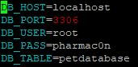

Example: .env file settings

# Software Installation

## Build Server

The System Administrator will need to log into PET server using putty or other preferred SSH agent as well as their valid username and password or SSH keys.

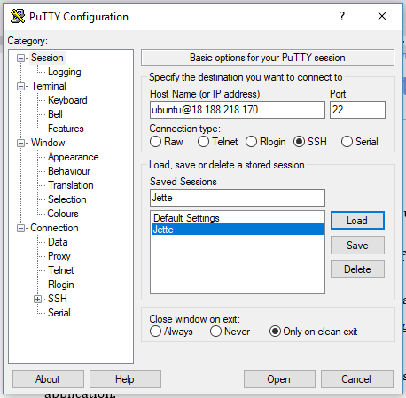

* The terminal window will be presented on successful login.  
  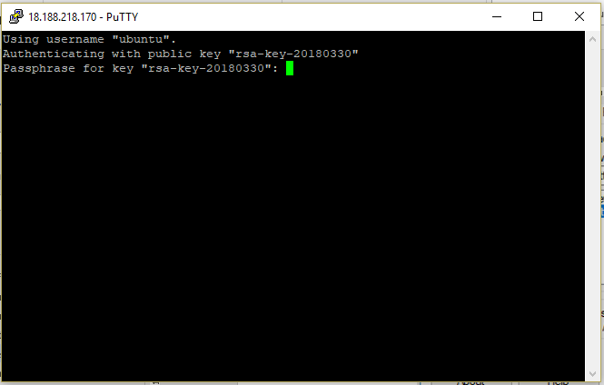  
  Enter your login for Putty at this point.  
  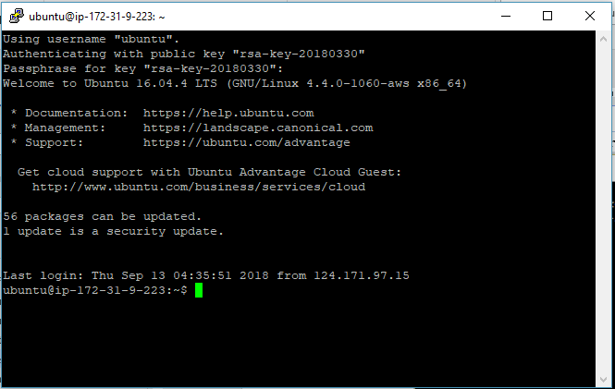

Once the user has logged in from the root directory (~) the user needs to clone the PET application from bitbucket by running the following command:

git clone <https://bitbucket.org/itc303teampharmacon/pharmacy_app.git>

The System Administrator will need to use their credentials to sign in and clone the PET application.

Once the file has been downloaded the following command needs to be run in order to give permissions to run the required setup scripts in manual:

*sudo chmod 777 pharmacy_app/scripts/buildserver.sh*

To configure the server for use, the user needs to run the following commands on the server:

1. *cd pharmacy_app/scripts/*
2. *./buildserver.sh build-server*

These commands will setup the configuration files as required and will create the server aliases that will be required to start the different aspects of the server.

# Managing the Server

## Starting the Web Server

To start the web server, now that the server has been built, the user can run the following command in the console to start the Web Server component of the PET application:

*pharmacon start-webserver*

## Starting the Metabase Report Server

To start the Metabase reporting server now that the server has been built, the user can run the following command in the console to start the Metabase Reporting Server component of the PET application*:

pharmacon start-metabase

NOTE:

* Please note that if the user has already started the Web Server in the terminal, they will need to make a new terminal session to the server to run the Metabase Reporting Server.

## Stopping the Web Server

To stop the web server now that the server has been built, the user can run the following command in the console to stop the Web Server component of the PET application:

*pharmacon stop-webserver*

## Stopping the Metabase Report Server

*To stop the Metabase reporting server* now that the server has been built, the user can run the following command in the console to *stop* the *Metabase Reporting Server component of the* PET application*:*

pharmacon stop-metabase

*RETURN TO CONTENTS PAGE*

# Login - Procedure

There are two authorisation levels for logins relating Pharmacy Error Tracker (P.E.T). The level of authority for the user will dictate the access the user has to P.E.T.

* General user: Access to Log an Error only
* Administrator user: Access to all functionality.

## Login – Administrator

User must have access to the application.

User must have a valid username and password

### To Log in to Pharmacy Error Tracker (PET):

1. Launch the application.
2. Click in the Username field.
3. Enter username.
4. Tab or click in Password field.
5. Enter password.

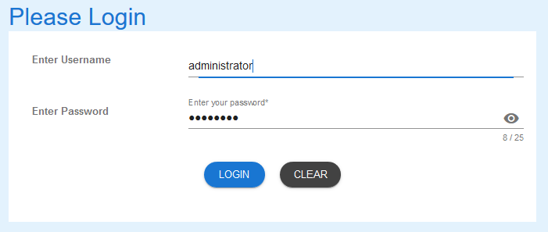

1. Select LOGIN to access PET.

## Login – General User

User must have access to the application.

User must have a valid username and password.

### To Log in to Pharmacy Error Tracker (PET):

1. Launch the application.
2. Click in the Username field.
3. Enter username.
4. Tab or click in Password field.
5. Enter password.

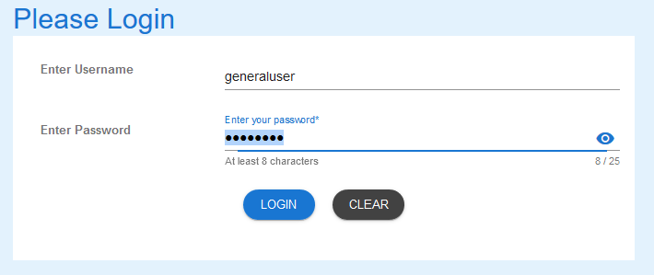

1. Select LOGIN to access PET.

NOTE:

Users entering an invalid username and/or password will not beable to access PET.

# Manage Users - Introduction

## Scope and Purpose

The purpose of this section of the User Manual is to provide instructions on how to Manage Users, i.e. add new user logins.

* To be able to use PET, the user will need basic knowledge of logging into an online application and using a manage function to create a record.
* This feature is only available to a user with administrator rights.

## Process Overview

The administrator will need to log into PET using their valid username and password (See 5.1).

* The Welcome Page will be presented on successful login.
* The administrator will need to select Manage Users via the menu bar or the button on the menu page.

## Manage Users - Process Steps

### Navigate to Manage Users

1. From the Welcome Page, there are two ways to navigate to “Manage Users”:
   1. Select the “Manage Users” from the list



* 1. From the Menu Bar, hover your mouse over “Manage…” and select “Manage Users”



1. The Add New User form will appear.

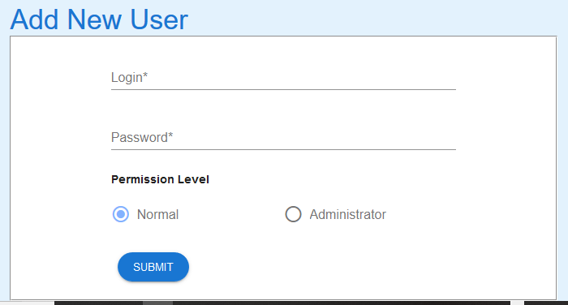

### Create User

1. Enter the details of the new User and a password.

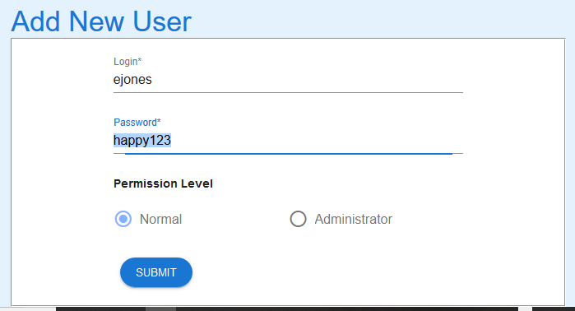

1. Select the SUBMIT button and success message appears.



1. Use the Search Users Guide for details to search the database to see record just created.

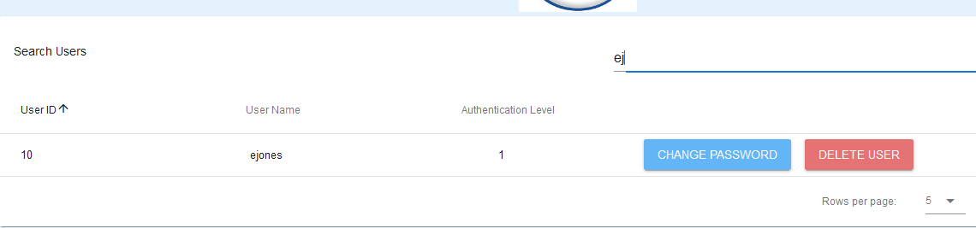

*RETURN TO CONTENTS PAGE*

# Search Users - Introduction

## Scope and Purpose

The purpose of this user guide is to provide instructions on how to search for a user (login) that has already been entered.

* To be able to use PET, the user will need basic knowledge of logging into an online application and using a search function to locate records.
* This feature is only available to a user with administrator rights.

## Process Overview

The administrator will need to log into PET using their valid username and password (See 5.1).

* The Welcome Page will be presented on successful login.
* The administrator will need to select Search Users via the menu bar or the button on the menu page.

The administrator will need to know the user’s login or part thereof for search purposes.

# Search Users - Procedure

To search for a user, the administrator will need to launch the application, login with a valid user name and password with administration rights. Using the search bar, the user will be able locate a user (login) or multiple users (logins) relating to the search criteria entered.

## Search Users – Process Steps

### Navigate to Search Users

1. From the Welcome Page, there are two ways to navigate to “Search Users”:
   1. Select the “Search Users” from the list



* 1. From the Menu Bar, hover your mouse over “Search…” and select “Search Users”

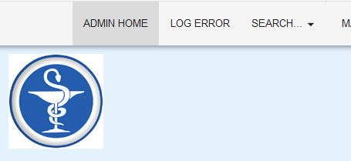

1. A list of users in the database will appear, showing the first five (5) entries.

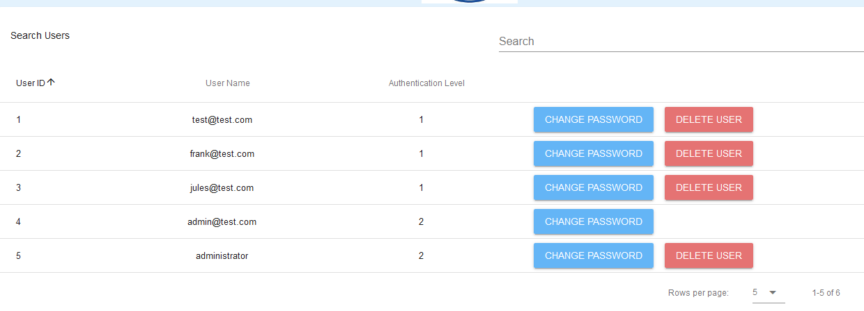

* 1. To change the number of records being shown, click on the drop-down arrow at the bottom-right corner and select number of records you wish to see.



### Search Users

1. To search for a specific record, enter the criteria in the search field located at the top-right corner.



1. The search criteria entered will find any record that matches that criteria in the fields shown in the headings. Entering a more detail criteria will narrow the number of records that are returned. Entering “n” returns 3 records of those available.  
     
   By entering “an” the search is narrowed further.

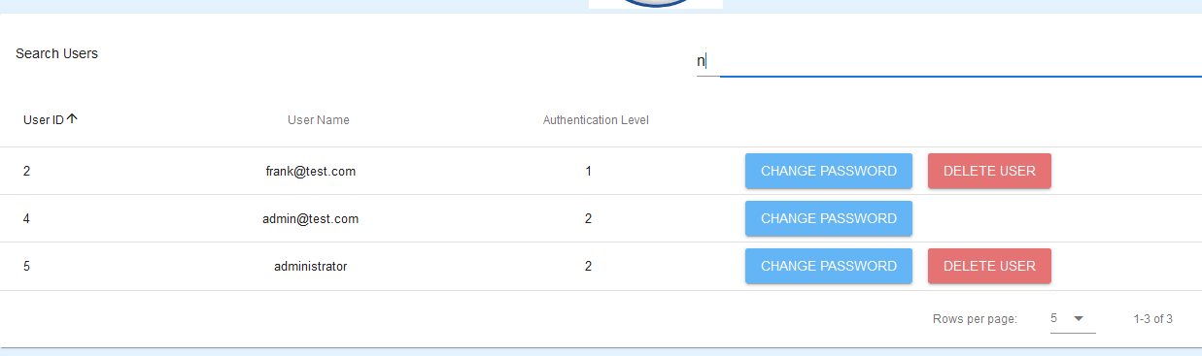

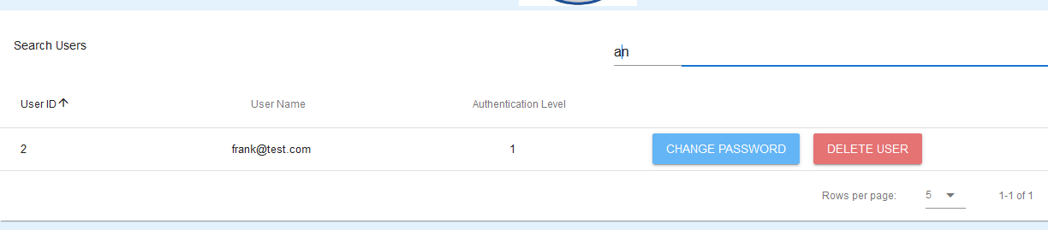

## Change Password

When the “Change Password” button is selected, the password for the user (login) can be changed. Please see the **Change Password Procedure** for guidance.

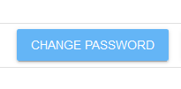

## Delete User

When the “Delete” button is selected, the user/login will be deleted. Please see the **Delete User Procedure** for guidance



RETURN TO CONTENTS PAGE

# Change Password - Introduction

## Scope and Purpose

The purpose of this user guide is to provide instructions on how to change the password for a user (login).

* To be able to use PET, the user will need basic knowledge of logging into an online application and using a search function to locate records.
* This feature is only available to a user with administrator rights.

## Process Overview

The administrator will need to log into PET using their valid username and password (See 5.1).

* The Welcome Page will be presented on successful login.
* The administrator will need to select Change password via the menu bar or the button on the menu page.

The administrator will need to know the user’s login or part thereof for search purposes.

# Change password - Procedure

To search for a user, the administrator will need to launch the application, login with a valid user name and password with administration rights. Using the search function, the administrator will be able locate a user (login) relating to the search criteria entered and be able to change the password.

## Locate User (login)

Administrator must have located the required user via the Search Users function.

### Load Change Password Form:

1. Select “Change Password” button.

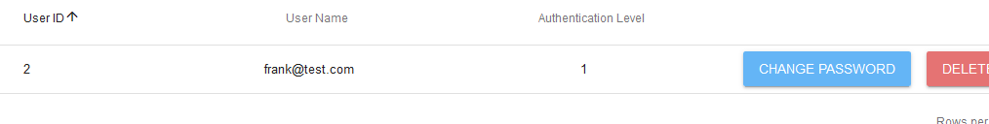

1. Change password form will load.

### Change Password Form:

Click in the “Password” field and enter a new password.

1. Password must be a minimum of 8 alpha/numerical characters with a maximum of 25.

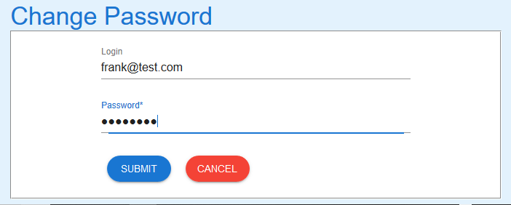

1. “Submit” button to update password for the user. Message that password was successfully update appears and then search screen reappears.

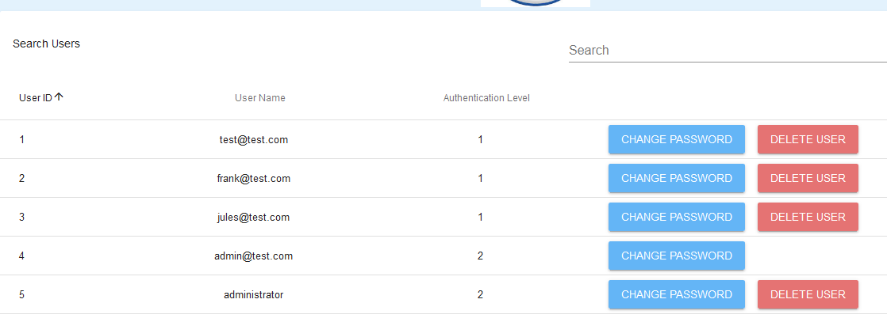

RETURN TO CONTENTS PAGE

# Delete User - Introduction

## Scope and Purpose

The purpose of this user guide is to provide instructions on how to delete a user that no longer requires access to the Pharmacy Error Tracker.

* To be able to use PET, the user will need basic knowledge of logging into an online application and using a search function to locate records.
* This feature is only available to a user with administrator rights.

## Process Overview

The administrator will need to log into PET using their valid username and password (See 5.1).

* The Welcome Page will be presented on successful login.
* The administrator will need to select Delete users via the menu bar or the button on the menu page.

The administrator will need to know the user’s login or part thereof for search purposes.

# Delete users

To search for a user, the administrator will need to launch the application, login with a valid user name and password with administration rights. Using the search function, the administrator will be able locate a user (login) relating to the search criteria entered and be able to change the password.

## Locate User (login)

Administrator must have located the required user via the Search Users function.

*NOTE: The administrator cannot delete themselves as the delete button is not available.*

### Search for User (Login):

1. Use the search bar to locate the user that is to be deleted. Select “Delete users” button.

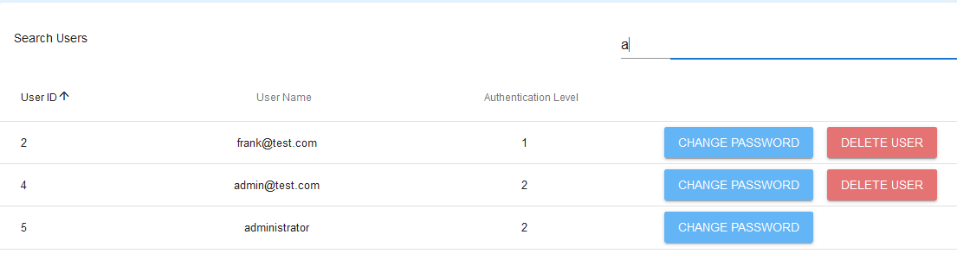

### Delete User:

Once the user to be deleted has been located, the delete user button is to be selected.

1. Select Delete User. Warning popup box will appear

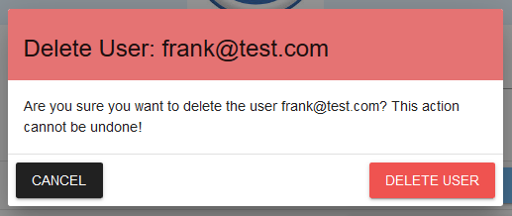

1. Check that the user (login) in the warning corresponds with user (login) to be deleted.
2. If the record selected is incorrect, select “Cancel”. The previous search screen will appear. Either start a new search or select correct record.

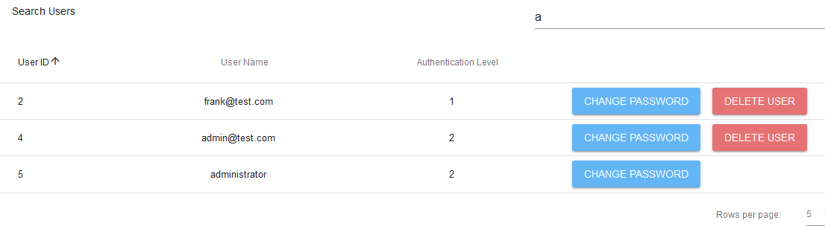

1. Once correct record has been selected, click “Delete User”

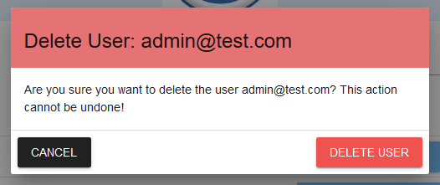

1. A message appears to indicate that the user (login) has been deleted and the previous search appears. The delete record will not appear in the results.

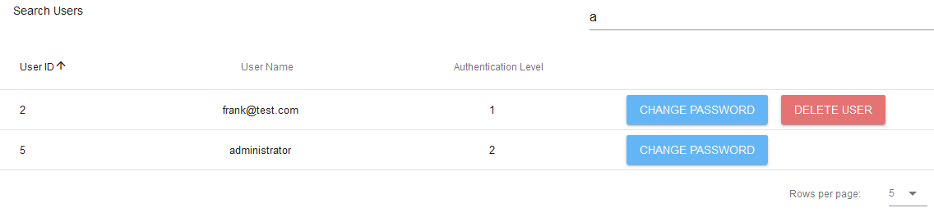

RETURN TO CONTENTS PAGE

# Edit Error Form - Introduction

## Scope and Purpose

The purpose of this user guide is to provide instructions on how to edit the error form, i.e. hide fields not required by the workplace, or restore hidden fields.

* To be able to use PET, the user will need basic knowledge of logging into an online application and using a manage function to create a record.
* This feature is only available to a user with administrator rights.

## Process Overview

The administrator will need to log into PET using their valid username and password (See 5.1).

* The Welcome Page will be presented on successful login.
* The administrator will need to select Manage Error Form via the menu bar or the button on the menu page.

# Edit Error Form - Procedure

To edit the error form, the administrator will need to launch the application, login with a valid user name and password with administration rights. Using the Manage Error Form, the administrator can manage the fields that will be available in the Log Error form.

NOTE: Only fields that are *not* able to be hidden are the date and time fields.

## Manage Error Form – Processing Steps

### To Edit Error Form

1. From the Welcome Page, there are two ways to navigate to “Manage Error Form”:
   1. Select the “Manage Error Form” from the list



* 1. From the Menu Bar, hover your mouse over “Manage…” and select “Manage Error Form”



1. The Edit Error form will appear.

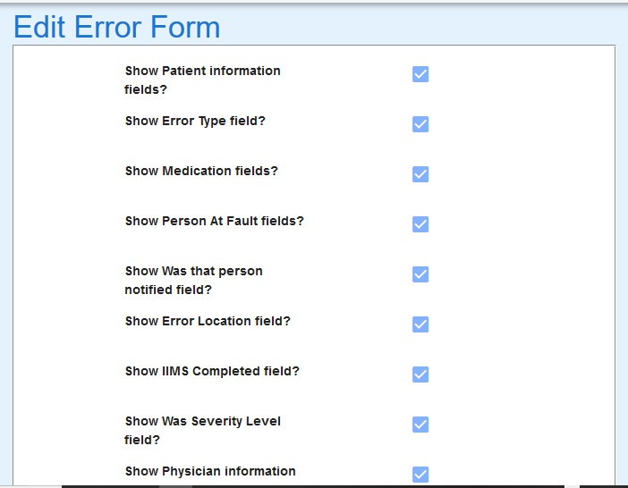

1. To hide fields from the Log Error form, “untick” the box relating to the fields to be hidden.

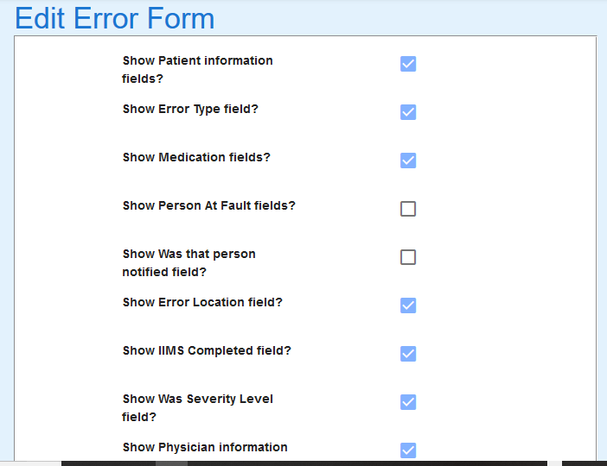

### Manage Edit Error Form changes

1. From Select the SUBMIT button to save changes, RESET TO DEFAULT to reset Log Error form to default (all fields showing), or UNDO CHANGES to cancel changes made.

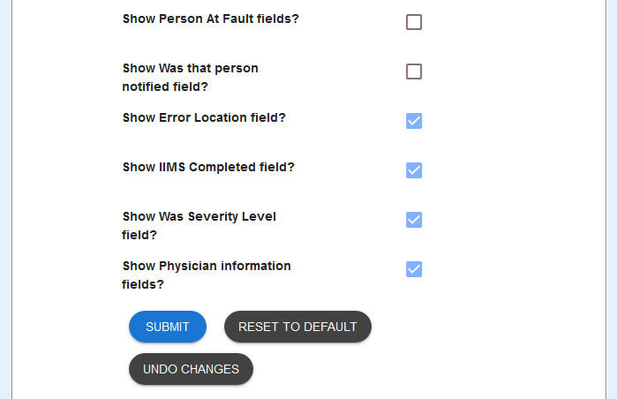

1. Form updated message is returned upon Submit being selected.



1. Form reset to default message is returned upon Reset To Default is selected. All field boxes are also ticked.



1. Undo success message is returned upon Undo Changes is selected. Field boxes that were unselected, are reset to selected.

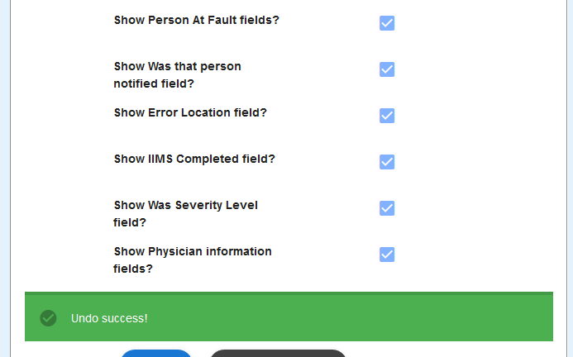

### Example of Edit Error Form changes

1. From Log Error form before changes are made to Person At Fault fields

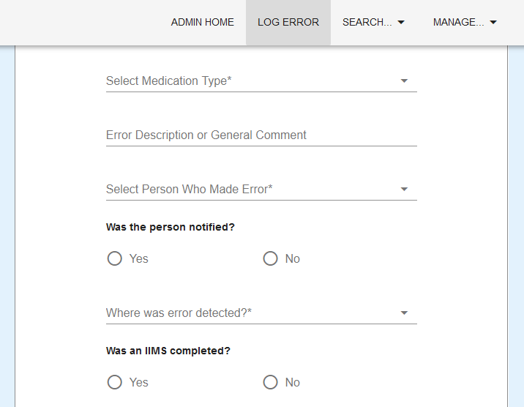

1. Changes made to Edit Error Form to hide Person At Fault and Was that Person Notified field.



1. Log Error form after changes have been submitted.  
     
   Arrow indicates where the hidden fields would normally appear.

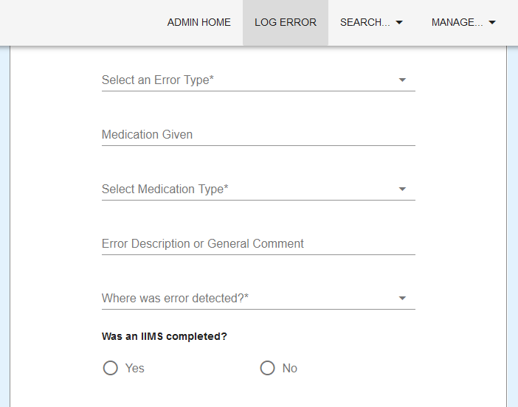

RETURN TO CONTENTS PAGE

# Log an Error - Introduction

## Scope and Purpose

The purpose of this user guide is to provide instructions for logging an error in the Pharmacy Error Tracker (PET). The user will be taken through the various steps required to successfully log an error.

* To be able to use PET, the user will need basic knowledge of logging into an online application and completing an online form.
* The process of logging an error is the same for both a general user and an administrator.

## Process Overview

The user will need to log into PET using a valid username and password already assigned to them by an administrator (See 5.1).

* For a general user, the Log Error form will appear on successful login.
* For an administrator, a menu page will be presented on successful login. The administrator will need to select Log Error via the menu bar or the button on the menu page.

The user will need to have all the following details concerning the error:

* Date error occurred
* Time error occurred
* Patient hospital ID
* Patient’s first name and surname
* Patient type (inpatient, outpatient, etc)
* Error type
* Medication given
* Medication type
* Any general comment about error as required
* Worker causing the error
* Whether the worker was notified
* Location of where the error was discovered (e.g., at the dispensary)
* Whether an IIMS was completed
* The severity of the error
* If the physician was notified
  + If notified, Physician provider number, first name, surname and any comment
* NOTE: Depending on the setup decided upon, not all fields mentioned will be available for input. See Edit Error Form User Guide.

# Log an Error - Procedure

To log an error, the user will need to launch the application, login with a valid user name and password, and complete the required fields in the form. The form is then submitted to update the database.

### To Complete the Log Error Form:

1. Enter the date of the error
2. Click in the Date field
3. Select the date the error occurred

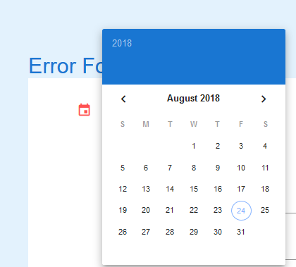

1. Enter the time of the error
   1. Click in the Time field
   2. Select the hour by click and holding on the highlighted “hand” and dragging to appropriate hour and releasing the mouse. You may also click on the appropriate hour.

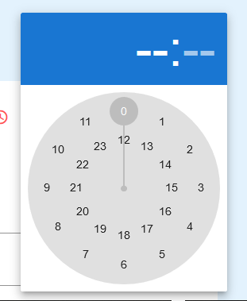

* 1. In the same way, select the appropriate minute (hold and drag method or click on required minute).

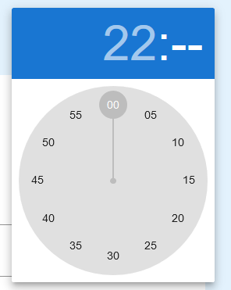

1. Enter details concerning the Patient:
   1. Patient MRN, First Name, and Surname

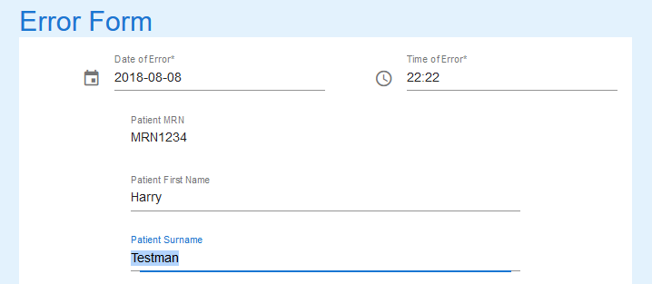

1. Select Patient Type by clicking in the field and selecting from the pop-up list

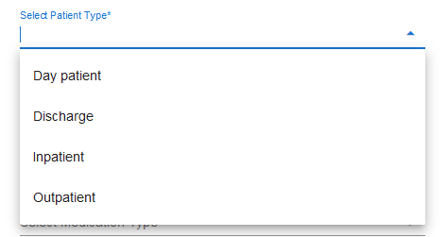

1. Click in Error Type field and select a type from the pop-up list

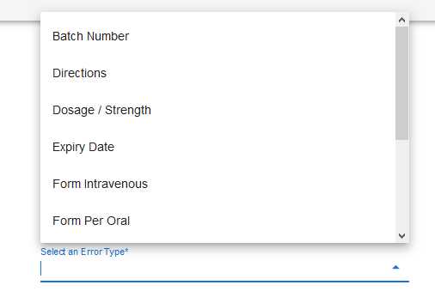

1. Enter the Medication Given in the next field

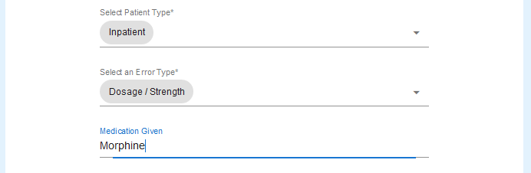

1. Select Medication Type by clicking in the next field and selecting from pop-up list

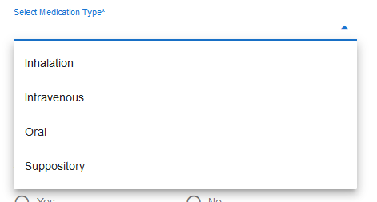

1. Enter an Error Description or General Comment if needed.
2. Select the staff member who made the error from the pop-up list

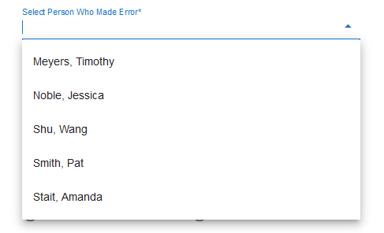

1. Select Yes if the staff member was advised of the error; otherwise select No

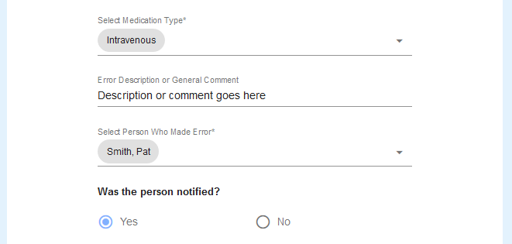

1. Click in the next field and select from the pop-up list where the error occurred

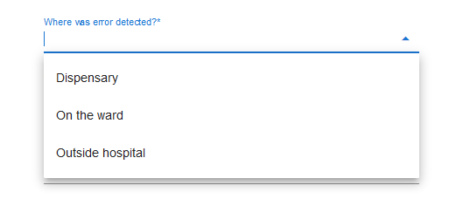

1. Select Yes if an IIMS was completed; No if it wasn’t

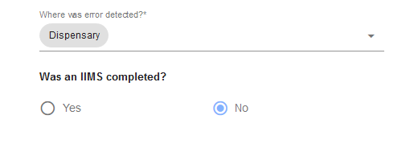

1. Select the severity level of the error by clicking in the next field and selecting from the pop-up list

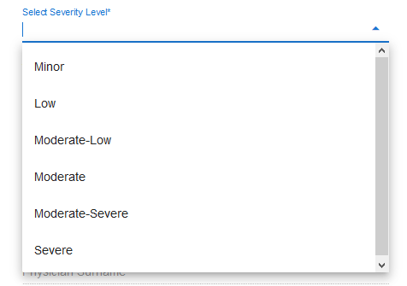

1. The next fields may not appear if the Administrator deems them as not required  
     
   If available, select Yes if Physician was notified; No otherwise.

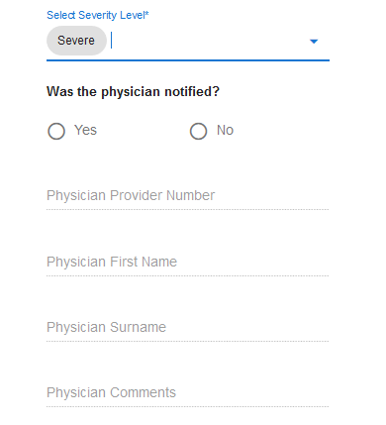

1. If **Yes** selected, enter the following details:
   1. Physician Provider Number
   2. Physician First Name
   3. Physician Surname
   4. Any comment the Physician may wish recorded

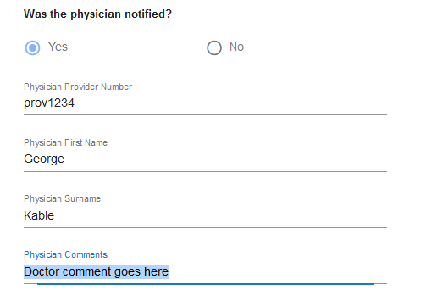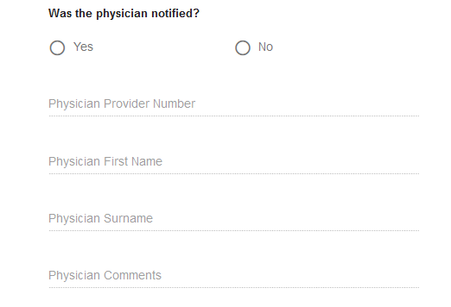

1. If **No** selected, no further details can be entered.
2. Select the Submit button if happy with details entered, Clear if you wish to start clear all fields and start again.



1. If the form is valid, the following message will appear



1. Select Clear to enter the next error.
2. Log out when all errors have been entered.

RETURN TO CONTENTS PAGE

# Search Errors - Introduction

## Scope and Purpose

The purpose of this user guide is to provide instructions on how to search for an error that has already been entered.

* To be able to use PET, the user will need basic knowledge of logging into an online application and using a search function to locate records.
* This feature is only available to a user with administrator rights.

## Process Overview

The administrator will need to log into PET using their valid username and password (see 5.1).

* The Welcome Page will be presented on successful login.
* The administrator will need to select Search Errors via the menu bar or the button on the menu page.

The user will need to have one of the following details concerning the error:

* Date error occurred
* Time error occurred
* Patient’s name
* Any general comment about error as required
* Physician’s name

# Search Errors - Procedure

To search for an error, the user will need to launch the application, login with a valid user name and password with administration rights. Using the search bar, the user will be able locate an error or multiple errors relating to the search criteria entered.

## Search Errors – Processing Steps

### Navigate to Search Errors

1. From the Welcome Page, there are two ways to navigate to “Search Errors”:
   1. Select the “Search Errors” from the list

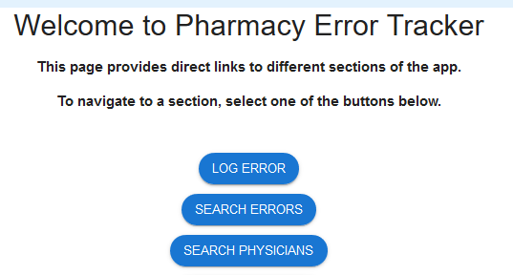

* 1. From the Menu Bar, hover your mouse over “Search…” and select “Search Errors”



1. A list of errors in the database will appear, showing the first five (5) entries.

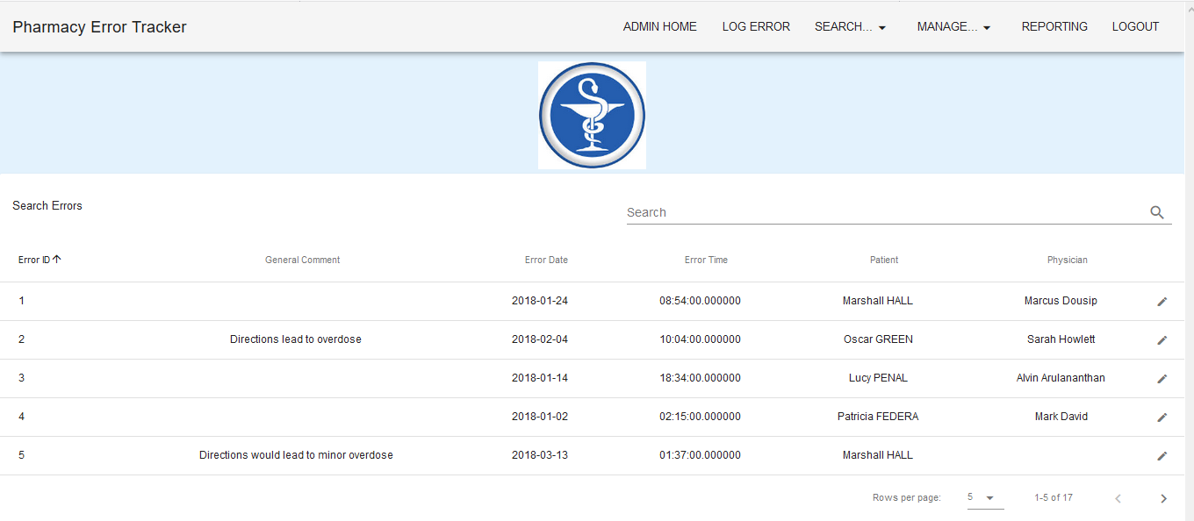

* 1. To change the number of records being shown, click on the drop-down arrow at the bottom-right corner and select number of records you wish to see.



### Search Errors

1. To search for a specific record, enter the criteria in the search field located at the top-right corner.



1. The search criteria entered will find any record that matches that criteria in the fields shown in the headings. Entering a more detail criteria will narrow the number of records that are returned. Entering “ha” returns 5 records of those available.  
     
   By entering “hall” the search is narrowed further.

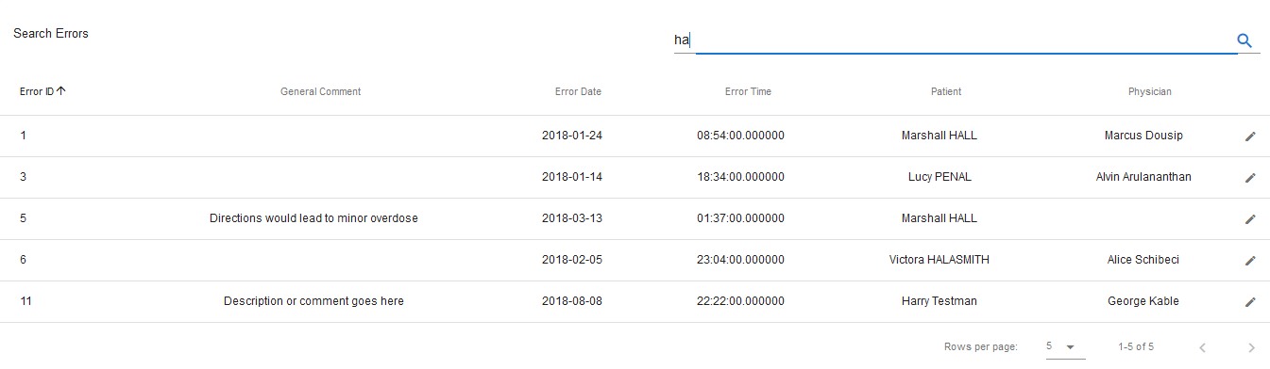

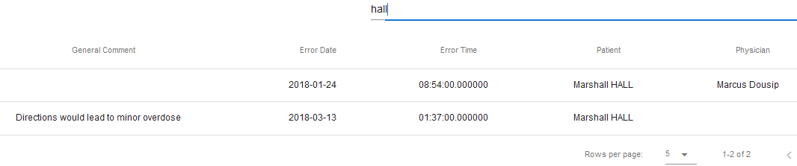

1. To see the full details of the error, select the record by clicking on the to the right of the record.

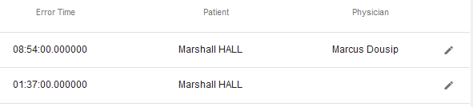

1. The selected record will load into the Log Error form, providing full error information

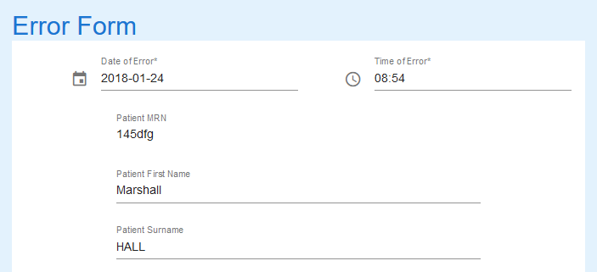

1. To search for another error record, repeat from step 1.

## Error Loaded into Log Error Form

Errors that have been loaded into the Log Error form because of a search can be amended and the record in the database updated. Please see the **Update Error Procedure** for guidance.

RETURN TO CONTENTS PAGE

# Update Error - Introduction

## Scope and Purpose

The purpose of this user guide is to provide instructions on how to update an error that has loaded into the Log Error Form through the search feature.

* To be able to use PET, the user will need basic knowledge of logging into an online application, completing an online form, and can use the search function of PET.
* This feature is only available to a user with administrator rights.
* This user guide will commence from the last step in **Search Errors Procedure**.

NOTE: The user must have a legitimate reason for amending/updating an error. For example, incorrect patient details entered, incorrect patient type entered, comment missed, incorrect spelling, etc.

## Process Overview

The administrator will need to log into PET using their valid username and password.

* The Welcome Page will be presented on successful login.
* The administrator will need to follow the User Guide - Search Errors to search and load the required error into the Log Error Form.

# Update an Error - Procedure

To search for an error, the user will need to launch the application, login with a valid user name and password with administration rights. Using the search bar, the user will be able locate an error or multiple errors relating to the search criteria entered. Once the error in question has been located, the administrator selects the error by clicking on the , loading the error into the Log Error form.

*NOTE: ALL fields in the form can be updated to correct information/fields that contain mistakes. Care needs to be taken to ensure correct information is not changed accidentally*.

## Locate Error Record

User must locate the error record via Search Errors.

### Upload Error record to Log Error Form.

1. Select the record to be amended by clicking on the  to the right of the record.

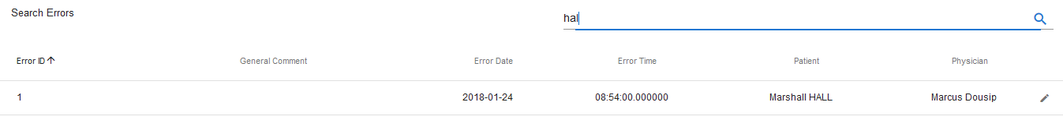

1. The record loads into the Log Error Form

## Update Error Details

### Locate field needing amendment:

1. Scroll down the form to find field containing incorrect information.
   1. If it is a list field, click on the dropdown arrow and select correct record.
   2. If it is a text field, correct mistake in the field

In the example above, the Error Type should be Dosage/Strength and the Medication Given should have been Xanax.

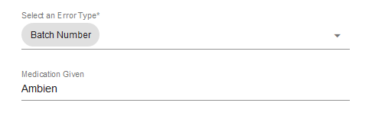

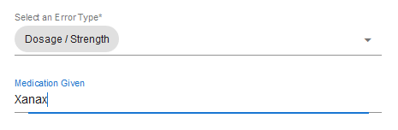

1. Select SUBMIT to update the record.



1. A successful update will receive the following message.



RETURN TO CONTENTS PAGE

# Manage Error Types - Introduction

## Scope and Purpose

The purpose of this user guide is to provide instructions on how to manage error types, i.e. add new error types.

* To be able to use PET, the user will need basic knowledge of logging into an online application and using a manage function to locate records.
* This feature is only available to a user with administrator rights.

## Process Overview

The administrator will need to log into PET using their valid username and password (See 5.1).

* The Welcome Page will be presented on successful login.
* The administrator will need to select Manage Error Types via the menu bar or the button on the menu page.

# Manage Error Types - Procedure

To manage an error type, the user will need to launch the application, login with a valid user name and password with administration rights. Using the Error Type Details form, the user can add new error types.

## Error Types – Process Steps

User must know what Error Types are to be added to the list.

### Navigate to Manage Error Types

1. From the Welcome Page, there are two ways to navigate to “Manage Error Types”:
   1. Select the “Manage Error Types” from the list



* 1. From the Menu Bar, hover your mouse over “Manage…” and select “Manage Error Types”



1. The Error Types Details form will appear.



## Create Error Types

User must know what Error Types are to be added to the list.

### Add Error Types

1. To Enter the details of the new Error Type.

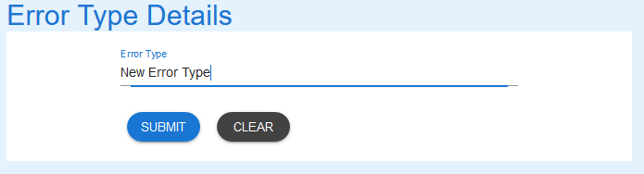

1. Select the SUBMIT button and success message appears.

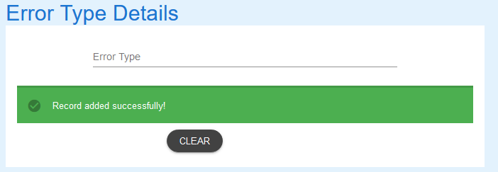

1. Use the Search Error Types User Guide for details to search the database to see record just created.

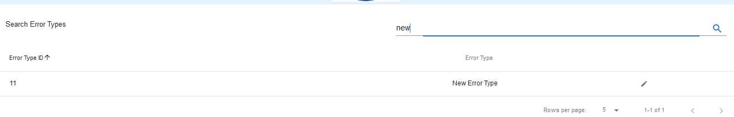

RETURN TO CONTENTS PAGE

# Search Error Types - Introduction

## Scope and Purpose

The purpose of this user guide is to provide instructions on how to search for an error type that has already been entered.

* To be able to use PET, the user will need basic knowledge of logging into an online application and using a search function to locate records.
* This feature is only available to a user with administrator rights.

## Process Overview

The administrator will need to log into PET using their valid username and password (See 5.1).

* The Welcome Page will be presented on successful login.
* The administrator will need to select Search Error Types via the menu bar or the button on the menu page.
* The user is to enter a search criterion.

# Search Error Types - Procedure

To search for an error type, the user will need to launch the application, login with a valid user name and password with administration rights. Using the search bar, the user will be able locate an error type or multiple error types relating to the search criteria entered.

## Search Error Types – Processing Steps

### Navigate to Search Error Types

1. From the Welcome Page, there are two ways to navigate to “Search Error Types”:
   1. Select the “Search Error Types” from the list

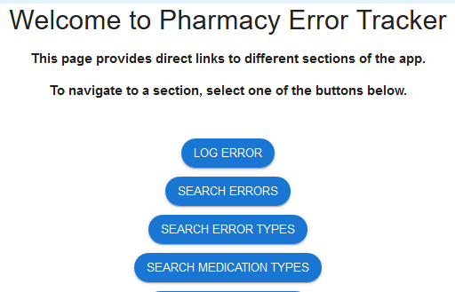

* 1. From the Menu Bar, hover your mouse over “Search…” and select “Search Error Types”



1. A list of error types in the database will appear, showing the first five (5) entries.

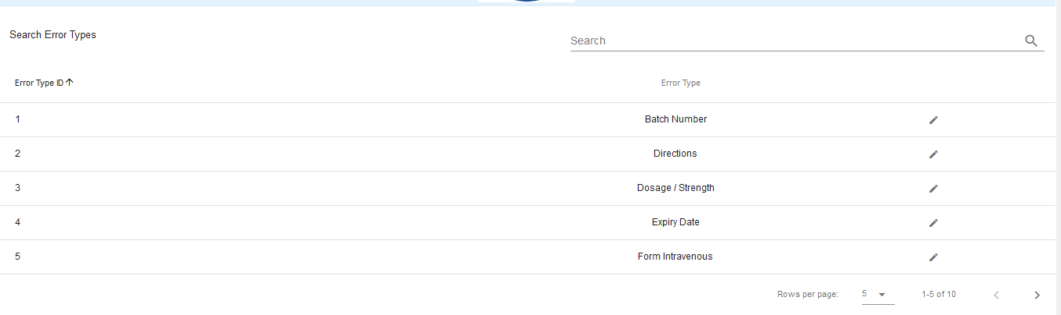

* 1. To change the number of records being shown, click on the drop-down arrow at the bottom-right corner and select number of records you wish to see.



### Search Error Types

1. To search for a specific record, enter the criteria in the search field located at the top-right corner.



1. The search criteria entered will find any record that matches that criteria in the fields shown in the headings. Entering a more detail criteria will narrow the number of records that are returned. Entering “d” returns 4 records of those available.  
     
   By entering “dos” the search is narrowed further.

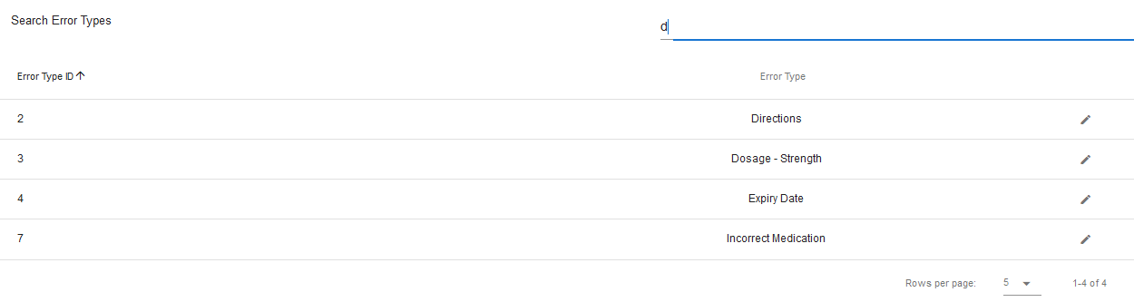

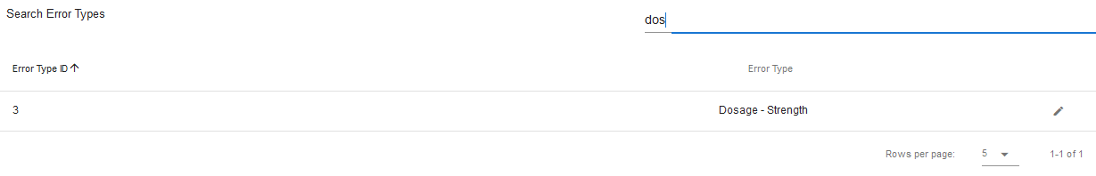

1. To search for another error type record, repeat from step 1.

## Error Type Update

Error types can be loaded into the Error Type Details form from a search, be amended and the record in the database updated. Please see the **Update Error Types - Procedure** for instruction.

RETURN TO CONTENTS PAGE

# Update Error Type - Introduction

## Scope and Purpose

The purpose of this user guide is to provide instructions on how to update an error type that has already been entered and requires correction.

* To be able to use PET, the user will need basic knowledge of logging into an online application and using a search function to locate records.
* To be able to search Error Types within PET.
* This feature is only available to a user with administrator rights.

## Process Overview

The administrator will need to log into PET using their valid username and password (See 5.1).

* The Welcome Page will be presented on successful login.
* The administrator will need to select Search Error Types via the menu bar or the button on the menu page.
* The user is to enter a search criterion.

# Update Error Types - Procedure

User must have located the error type via Search Error Types.

User must know what the field is to be updated to.

## Update Error Type – Processing Steps

User must have access to the application.

User must have a valid username and password with administration rights.

### To Update an Error Type:

1. To update details of the error type, select the record by clicking on the to the right of the record.

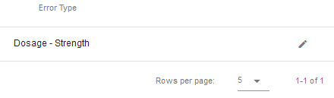

1. The selected record will load into the Error Type Details form, providing full error type information

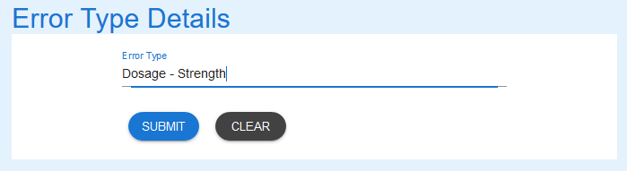

1. Amend the record as required.

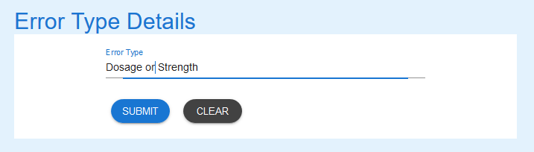

1. Select the “Submit” button to update the record in the database. A message stating record has been updated successfully is returned.

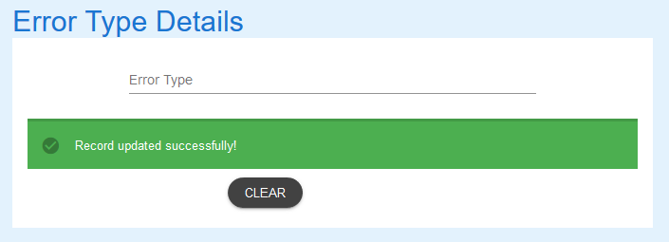

1. A search for “dos” shows the record has been updated

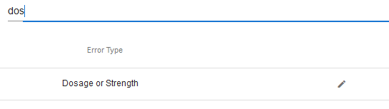

RETURN TO CONTENTS PAGE

# Manage Medication Types - Introduction

## Scope and Purpose

The purpose of this user guide is to provide instructions on how to manage medication types, i.e. add new medication types.

* To be able to use PET, the user will need basic knowledge of logging into an online application and using a manage function to locate records.
* This feature is only available to a user with administrator rights.

## Process Overview

The administrator will need to log into PET using their valid username and password.

* The Welcome Page will be presented on successful login.
* The administrator will need to select Manage Medication Types via the menu bar or the button on the menu page.

# Manage Medication Types - Procedure

To manage a medication type, the user will need to launch the application, login with a valid user name and password with administration rights. Using the Medication Type Details form, the user can add new medication types.

## Medication Types – Processing Steps

### Navigate to Medication Types

1. From the Welcome Page, there are two ways to navigate to “Manage Medication Types”:
   1. Select the “Manage Medication Types” from the list



* 1. From the Menu Bar, hover your mouse over “Manage…” and select “Manage Medication Types”



1. The Medication Types Details form will appear.

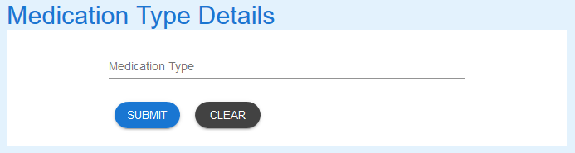

### Create Medication Types

1. Enter the details of the new Medication Type.



1. Select the SUBMIT button and success message appears.

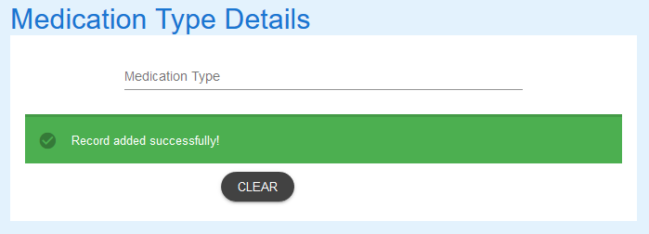

1. Go to **Search Medication Types Procedures** for details to search the database to see record just created.

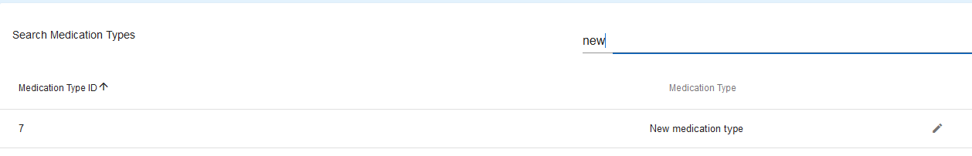

RETURN TO CONTENTS PAGE

# Search Medication Types - Introduction

## Scope and Purpose

The purpose of this user guide is to provide instructions on how to search for a medication type that has already been entered.

* To be able to use PET, the user will need basic knowledge of logging into an online application and using a search function to locate records.
* This feature is only available to a user with administrator rights.

## Process Overview

The administrator will need to log into PET using their valid username and password (see 5.1).

* The Welcome Page will be presented on successful login.
* The administrator will need to select Search Medication Types via the menu bar or the button on the menu page.
* The user is to enter a search criterion.

# Search Medication Types - Procedures

To search for a medication type, the user will need to launch the application, login with a valid user name and password with administration rights. Using the search bar, the user will be able locate a medication type or multiple medication types relating to the search criteria entered.

## Search Medication Types – Processing Steps

### Navigate to Search Medication Types

1. From the Welcome Page, there are two ways to navigate to “Search Medication Types”:
   1. Select the “Search Medication Types” from the list



* 1. From the Menu Bar, hover your mouse over “Search…” and select “Search Medication Types”



1. A list of medication types in the database will appear, showing the first five (5) entries.

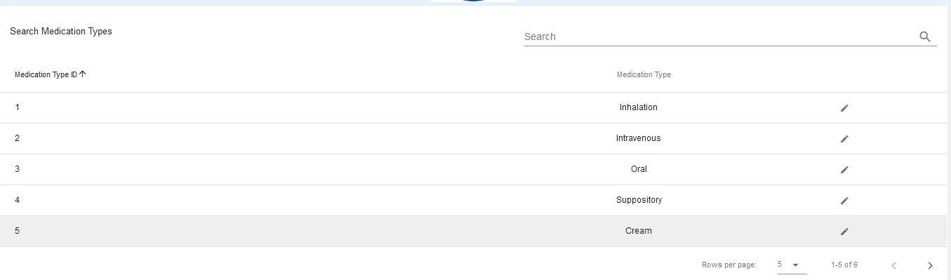

* 1. To change the number of records being shown, click on the drop-down arrow at the bottom-right corner and select number of records you wish to see.



### Search Medication Types

1. To search for a specific record, enter the criteria in the search field located at the top-right corner.



1. The search criteria entered will find any record that matches that criteria in the fields shown in the headings. Entering a more detail criteria will narrow the number of records that are returned. Entering “i” returns 3 records of those available.  
     
   By entering “in” the search is narrowed further.

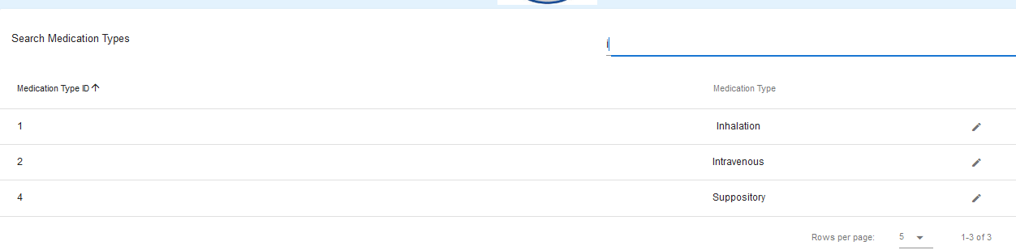

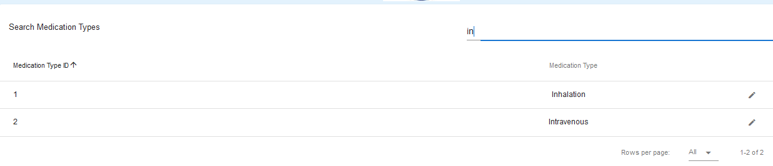

1. To search for another medication type record, repeat from step 1.

## Medication Type Update

Medication types can be loaded into the Medication Type Details form from a search, be amended and the record in the database updated. Please see the **Update Medication Types Procedure** for instruction.

RETURN TO CONTENTS PAGE

# Update Medication Types - Introduction

## Scope and Purpose

The purpose of this user guide is to provide instructions on how to update an error type that has already been entered and requires correction.

* To be able to use PET, the user will need basic knowledge of logging into an online application and using a search function to locate records.
* To be able to search Medication Types within PET.
* This feature is only available to a user with administrator rights.

## Process Overview

The administrator will need to log into PET using their valid username and password (See 5.1).

* The Welcome Page will be presented on successful login.
* The administrator will need to select Search Medication Types via the menu bar or the button on the menu page.
* The user is to enter a search criterion.

# Update Medication Types - Procedure

User must have located the medication type via Search Medication Types.

## Update Medication Type – Processing Steps

User must have access to the application.

User must have a valid username and password with administration rights.

### To Update a Medication Type:

1. To update details of the medication type, select the record by clicking on the to the right of the record.

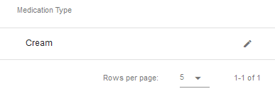

1. The selected record will load into the Medication Type Details form, providing full medication type information



1. Amend the record as required.



1. Select the “Submit” button to update the record in the database. A message stating record has been updated successfully is returned.

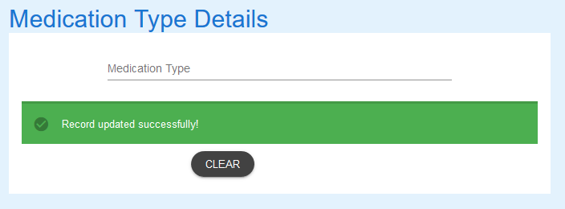

1. A search for “em” shows the record has been updated

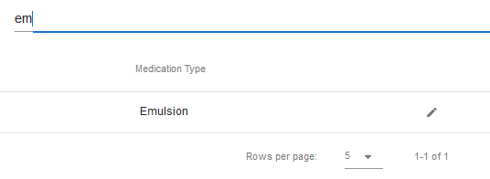

RETURN TO CONTENTS PAGE

# Manage Patient Types - Introduction

## Scope and Purpose

The purpose of this user guide is to provide instructions on how to manage patient types, i.e. add new patient types.

* To be able to use PET, the user will need basic knowledge of logging into an online application and using a manage function to locate records.
* This feature is only available to a user with administrator rights.

## Process Overview

The administrator will need to log into PET using their valid username and password (see 5.1).

* The Welcome Page will be presented on successful login.
* The administrator will need to select Manage Patient Types via the menu bar or the button on the menu page.

# Manage Patient Types - Procedure

To manage a patient type, the user will need to launch the application, login with a valid user name and password with administration rights. Using the Patient Type Details form, the user can add new patient types.

## Manage Patient Types

### Navigate to Manage Patient Types

1. From the Welcome Page, there are two ways to navigate to “Manage Patient Types”:
   1. Select the “Manage Patient Types” from the list



* 1. From the Menu Bar, hover your mouse over “Manage…” and select “Manage Patient Types”



1. The Patient Types Details form will appear.



### Create Patient Types

1. Enter the details of the new Patient Type.

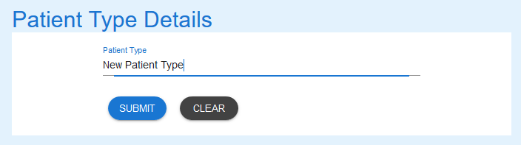

1. Select the SUBMIT button and success message appears.

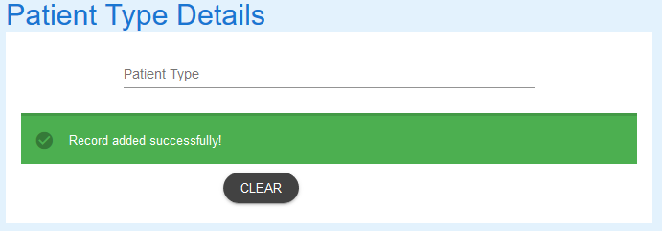

1. Go to **Search Patient Types Procedure** for details to search the database to see record just created.

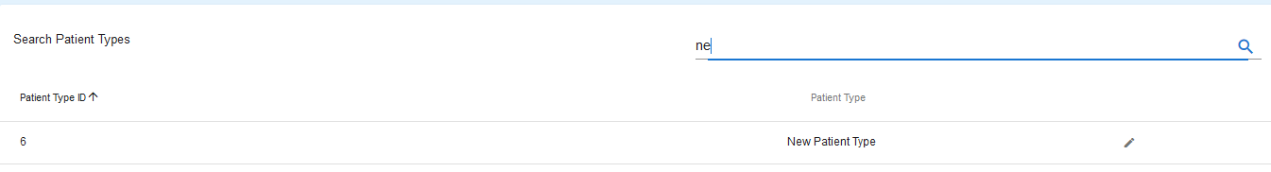

RETURN TO CONTENTS PAGE

# Search Patient Types - Introduction

## Scope and Purpose

The purpose of this user guide is to provide instructions on how to search for a patient type that has already been entered.

* To be able to use PET, the user will need basic knowledge of logging into an online application and using a search function to locate records.
* This feature is only available to a user with administrator rights.

## Process Overview

The administrator will need to log into PET using their valid username and password (see 5.1).

* The Welcome Page will be presented on successful login.
* The administrator will need to select Search Patient Types via the menu bar or the button on the menu page.
* The user is to enter a search criterion.

# Search Patient Types - Procedure

To search for a patient type, the user will need to launch the application, login with a valid user name and password with administration rights. Using the search bar, the user will be able locate a patient type or multiple patient types relating to the search criteria entered.

## Search Patient Types – Processing Steps

### Navigate to Search Patient Types

1. From the Welcome Page, there are two ways to navigate to “Search Patient Types”:
   1. Select the “Search Patient Types” from the list

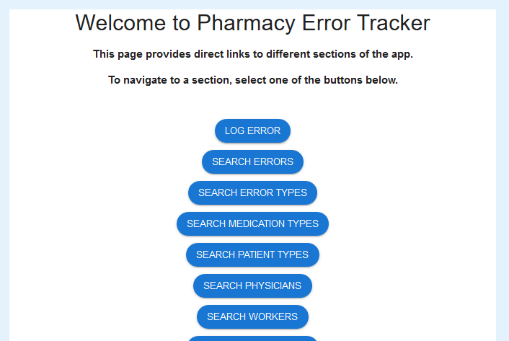

* 1. From the Menu Bar, hover your mouse over “Search…” and select “Search Patient Types”



1. A list of patient types in the database will appear, showing the first five (5) entries.

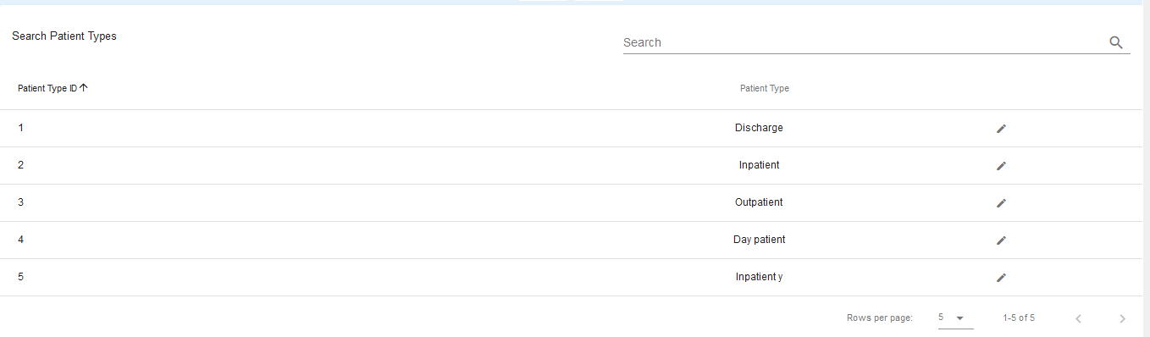

* 1. To change the number of records being shown, click on the drop-down arrow at the bottom-right corner and select number of records you wish to see.



### Search Patient Types

1. From To search for a specific record, enter the criteria in the search field located at the top-right corner.



1. The search criteria entered will find any record that matches that criteria in the fields shown in the headings. Entering a more detail criteria will narrow the number of records that are returned. Entering “d” returns 2 records of those available.  
     
   By entering “da” the search is narrowed further.

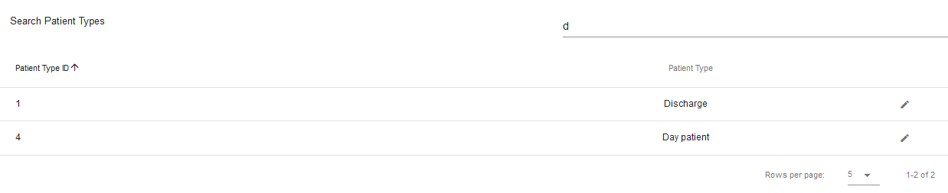

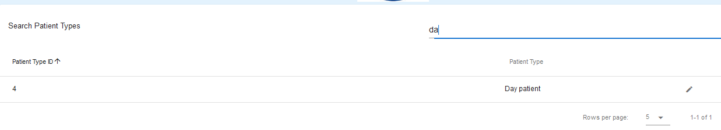

1. To search for another patient type record, repeat from step 1.

## Patient Type Update

Patient types can be loaded into the Patient Type Details form from a search, be amended and the record in the database updated. Please see the **Update Patient Types Procedures** for instruction.

RETURN TO CONTENTS PAGE

# Update Patient Types - Introduction

## Scope and Purpose

The purpose of this user guide is to provide instructions on how to update an error type that has already been entered and requires correction.

* To be able to use PET, the user will need basic knowledge of logging into an online application and using a search function to locate records.
* To be able to search Patient Types within PET.
* This feature is only available to a user with administrator rights.

## Process Overview

The administrator will need to log into PET using their valid username and password (see 5.1).

* The Welcome Page will be presented on successful login.
* The administrator will need to select Search Patient Types via the menu bar or the button on the menu page.
* The user is to enter a search criterion.

# Update Patient Types - Procedure

User must have located the required record via Search Patient Types.

## Update Patient Type – Processing Steps

User must have access to the application.

User must have a valid username and password with administration rights.

### To Update a Patient Type:

1. To update details of the patient type, select the record by clicking on the to the right of the record.

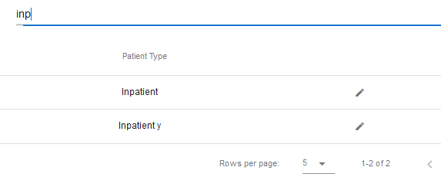

1. The selected record will load into the Patient Type Details form, providing full patient type information

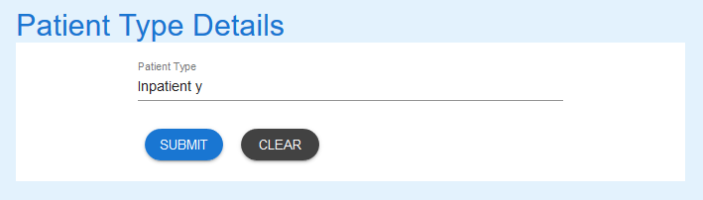

1. Amend the record as required.

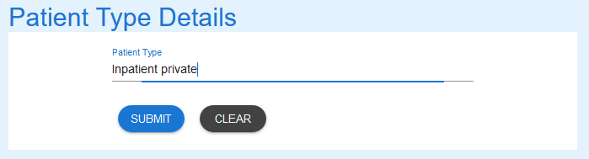

1. Select the “Submit” button to update the record in the database. A message stating record has been updated successfully is returned.

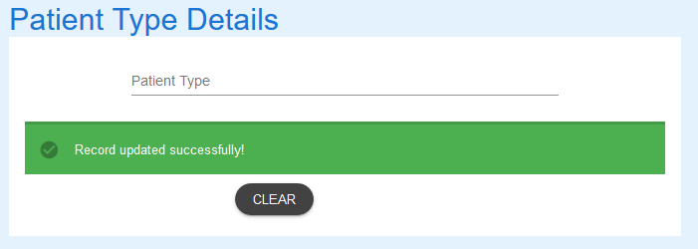

1. A search for “priv” shows the record has been updated

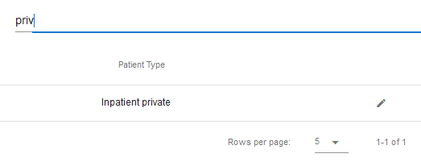

*RETURN TO CONTENTS PAGE*

# Search Physicians - Introduction

## Scope and Purpose

The purpose of this user guide is to provide instructions on how to search for a physician that has already been entered.

* To be able to use PET, the user will need basic knowledge of logging into an online application and using a search function to locate records.
* This feature is only available to a user with administrator rights.
* NOTE:

New Physicians are added via the Log Error Form.

## Process Overview

The administrator will need to log into PET using their valid username and password (see 5.1).

* The Welcome Page will be presented on successful login.
* The administrator will need to select Search Physician via the menu bar or the button on the menu page.
* The user is to enter a search criterion.

# Search Physician - Procedure

To search for a physician, the user will need to launch the application, login with a valid user name and password with administration rights. Using the search bar, the user will be able locate a physician or multiple physicians relating to the search criteria entered.

## Search Physicians – Processing Steps

### Navigate to Search Physicians

1. From the Welcome Page, there are two ways to navigate to “Search Physician”:
   1. Select the “Search Physician” from the list



* 1. From the Menu Bar, hover your mouse over “Search…” and select “Search Physician”



1. A list of physicians in the database will appear, showing the first five (5) entries.

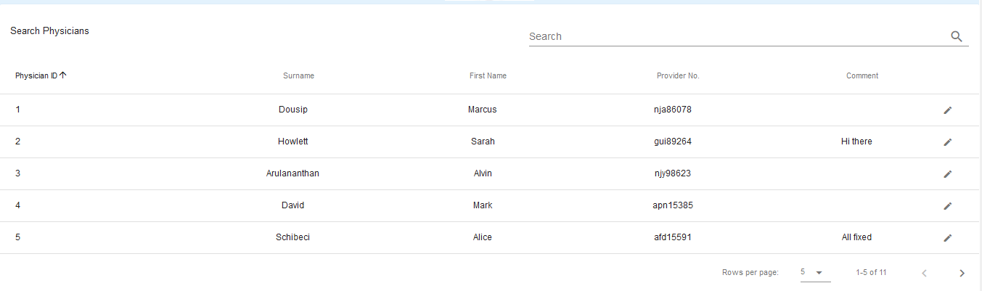

* 1. To change the number of records being shown, click on the drop-down arrow at the bottom-right corner and select number of records you wish to see.



### Search Physicians

1. To search for a specific record, enter the criteria in the search field located at the top-right corner.



1. The search criteria entered will find any record that matches that criteria in the fields shown in the headings. Entering a more detail criteria will narrow the number of records that are returned. Entering “ma” returns 5 records of those available.  
     
   By entering “marc” the search is narrowed further.

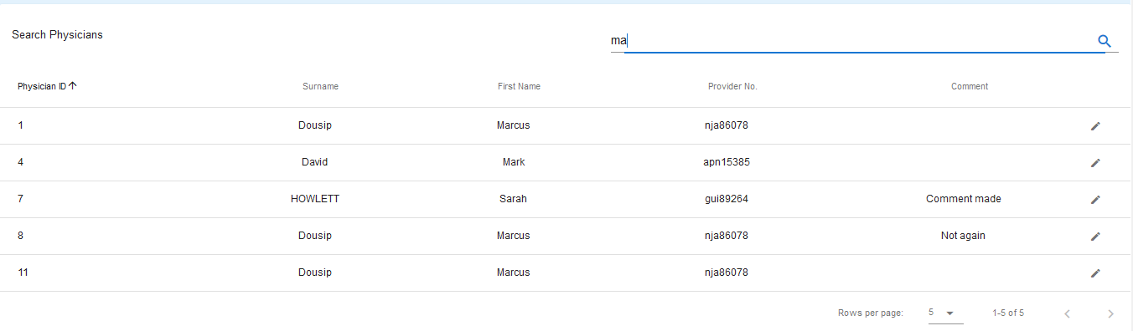

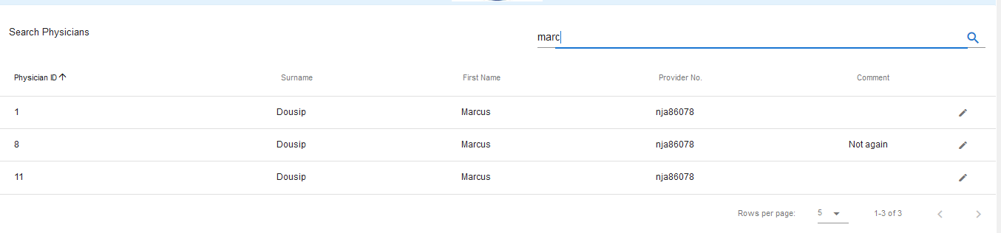

1. To search for another physician record, repeat from step 1.

## Physician Update

A physician record can be loaded into the Physician Details form from a search, be amended and the record in the database updated. Please see the **Update Physicians Procedure** for instruction.

RETURN TO CONTENTS PAGE

# Update Physicians - Introduction

## Scope and Purpose

The purpose of this user guide is to provide instructions on how to update a physician that has loaded into the Physician Details Form through the search feature.

* To be able to use PET, the user will need basic knowledge of logging into an online application, completing an online form, and can use the search function of PET.
* This feature is only available to a user with administrator rights.
* This user guide will commence from the last step in User Guide – Search Physicians.

NOTE: The user must have a legitimate reason for amending/updating a physician record. For example, incorrect spelling, missed adding a comment, etc.

## Process Overview

The administrator will need to log into PET using their valid username and password (see 5.1).

* The Welcome Page will be presented on successful login.
* The administrator will need to follow the User Guide - Search Physicians to search for the required record.

# Update an Physician - Procedure

User must have located the required record via Search Physicians.

*NOTE: ALL fields in the form can be updated to correct information/fields that contain mistakes. Care needs to be taken to ensure correct information is not changed accidentally*.

## Update Physician Record – Processing Steps

User must have access to the application.

User must have a valid username and password with administration rights.

### Upload Physician record to Physician Details Form.

1. Select the record to be amended by clicking on the  to the right of the record.

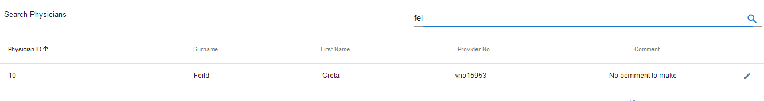

1. The record loads into the Physician Details Form

## Change Details

### Locate field needing amendment:

1. Locate the field containing incorrect information. Click in the field and amend the details as required  
   In the example above, the Surname and the Physician Comment have spelling errors.

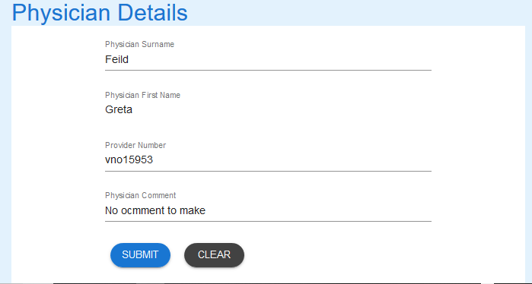

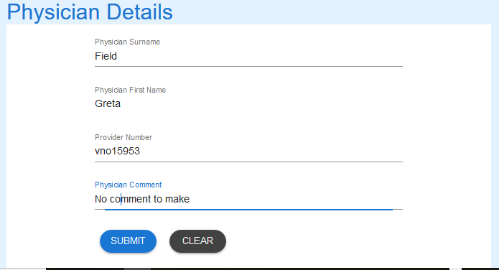

1. Select SUBMIT to update the record.



1. A successful update will receive the following message.



RETURN TO CONTENTS PAGE

# Manage Workers - Introduction

## Scope and Purpose

The purpose of this user guide is to provide instructions on how to manage workers, i.e. add new workers.

* To be able to use PET, the user will need basic knowledge of logging into an online application and using a manage function to locate records.
* This feature is only available to a user with administrator rights.

## Process Overview

The administrator will need to log into PET using their valid username and password (see 5.1).

* The Welcome Page will be presented on successful login.
* The administrator will need to select Manage Workers via the menu bar or the button on the menu page.

# Manage Workers - Procedures

To manage workers, the user will need to launch the application, login with a valid user name and password with administration rights. Using the Workers Details form, the user can add new workers.

## Manage Workers – Processing Steps

### Navigate to Manage Workers

1. From the Welcome Page, there are two ways to navigate to “Manage Workers”:
   1. Select the “Manage Workers” from the list



* 1. From the Menu Bar, hover your mouse over “Manage…” and select “Manage Workers”



1. The Workers Details form will appear.

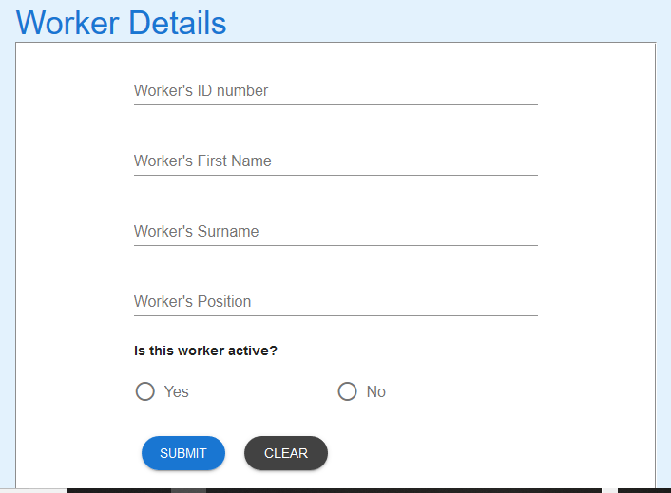

### Create New Worker

1. Enter the details of the new Worker. The worker id must **not** have been used before.

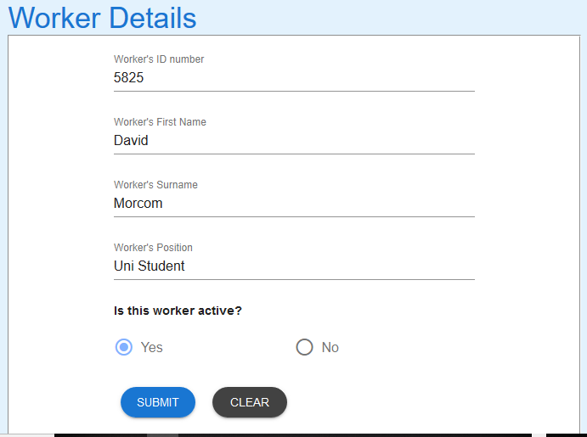

1. Select the SUBMIT button and success message appears.



1. Go **Search Workers Procedure** for details on how to search the database to see record just created.

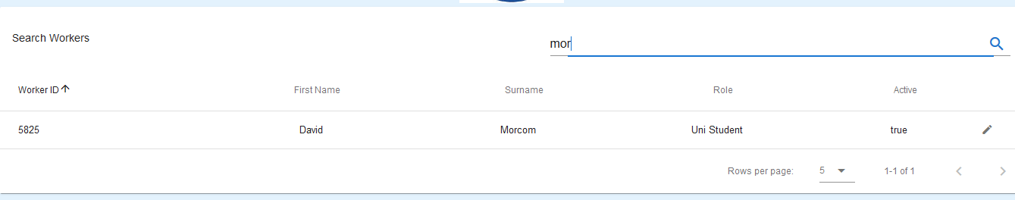

*RETURN TO CONTENTS PAGE*

# Introduction

## Scope and Purpose

The purpose of this user guide is to provide instructions on how to search for a worker that has already been entered.

* To be able to use PET, the user will need basic knowledge of logging into an online application and using a search function to locate records.
* This feature is only available to a user with administrator rights.

## Process Overview

The administrator will need to log into PET using their valid username and password (see 5.1).

* The Welcome Page will be presented on successful login.
* The administrator will need to select Search Worker via the menu bar or the button on the menu page.
* The user is to enter a search criterion.

# Search Workers - Procedure

To search for a worker, the user will need to launch the application, login with a valid user name and password with administration rights. Using the search bar, the user will be able locate a worker or multiple workers relating to the search criteria entered.

## Search Workers – Processing Steps

### Navigate to Search Workers

1. From the Welcome Page, there are two ways to navigate to “Search Workers”:
   1. Select the “Search Workers” from the list



* 1. From the Menu Bar, hover your mouse over “Search…” and select “Search Workers”



1. A list of workers in the database will appear, showing the first five (5) entries.

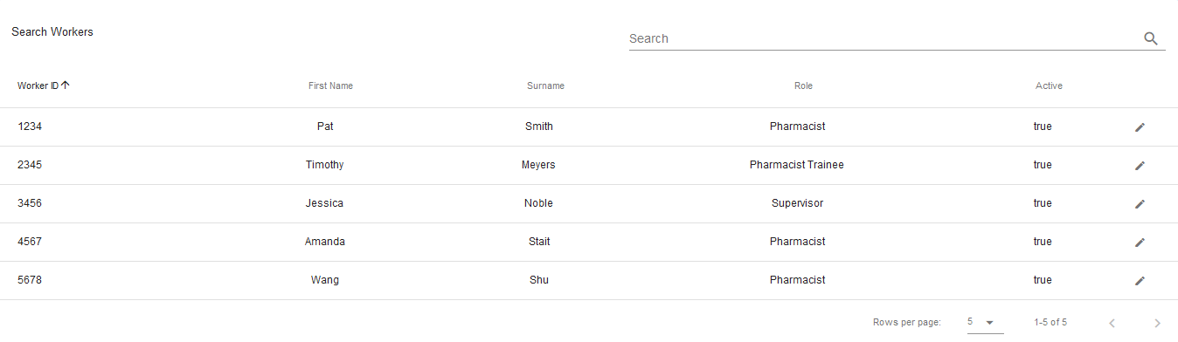

* 1. To change the number of records being shown, click on the drop-down arrow at the bottom-right corner and select number of records you wish to see.



### Search Workers

1. To search for a specific record, enter the criteria in the search field located at the top-right corner.



1. The search criteria entered will find any record that matches that criteria in the fields shown in the headings. Entering a more detail criteria will narrow the number of records that are returned. Entering “3” returns three (3) records of those available.  
     
   By entering “3456” the search is narrowed further.

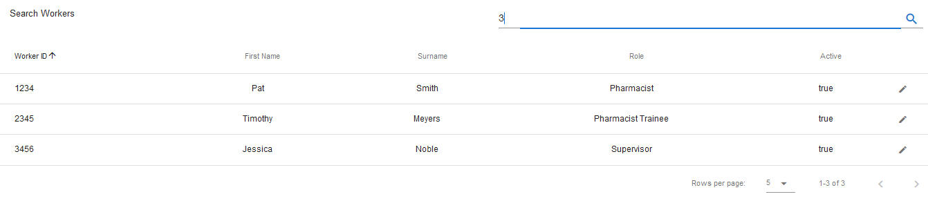

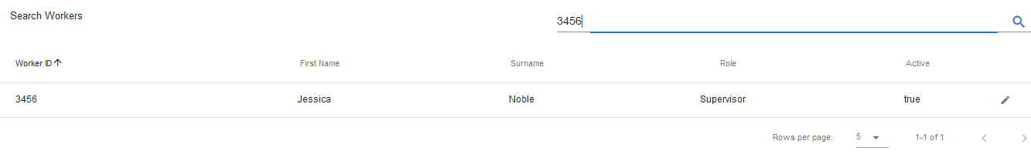

1. To search for another worker record, repeat from step 1b.

## Worker Update

A worker record can be loaded into the Worker Details form from a search, be amended and the record in the database updated. Please see the **Update Workers Procedure** for instruction.

RETURN TO CONTENTS PAGE

# Update Workers - Introduction

## Scope and Purpose

The purpose of this user guide is to provide instructions on how to update a worker that has loaded into the Worker Details Form through the search feature.

* To be able to use PET, the user will need basic knowledge of logging into an online application, completing an online form, and can use the search function of PET.
* This feature is only available to a user with administrator rights.
* This user guide will commence from the last step in User Guide – Search Workers.

NOTE: The user must have a legitimate reason for amending/updating a worker record. For example, incorrect spelling, missed adding a comment, etc.

## Process Overview

The administrator will need to log into PET using their valid username and password (see 5.1).

* The Welcome Page will be presented on successful login.
* The administrator will need to follow the User Guide - Search Workers to search for the required record.

# Update Workers - Procedures

User must have located the required record via Search Workers.

*NOTE: All fields except the* Worker ID *in the form can be updated to correct information/fields that contain mistakes. Care needs to be taken to ensure correct information is not changed accidentally*.

## Locate Worker Record – Processing Steps

User must have access to the application.

User must have a valid username and password with administration rights.

### Upload Worker record to Worker Details Form

1. Select the record to be amended by clicking on the  to the right of the record.

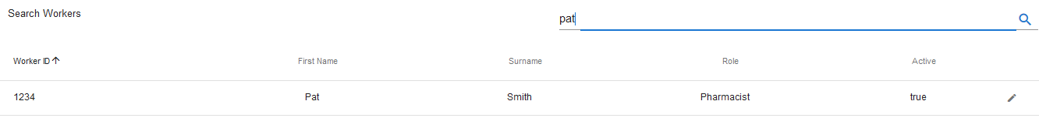

1. The record loads into the Worker Details Form

## Update Worker Details

### Locate field needing amendment

1. Locate the field containing incorrect information. Click in the field and amend the details as required. *Worker’s ID cannot be changed*   
   In the example above, the worker’s position should be Locum.

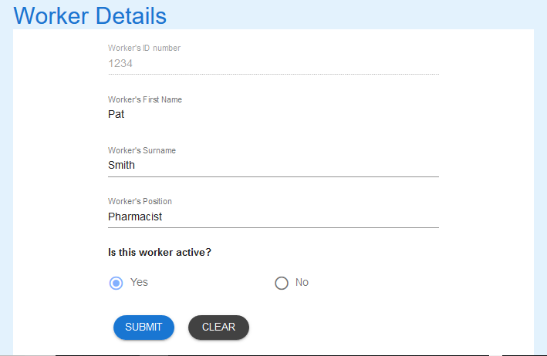

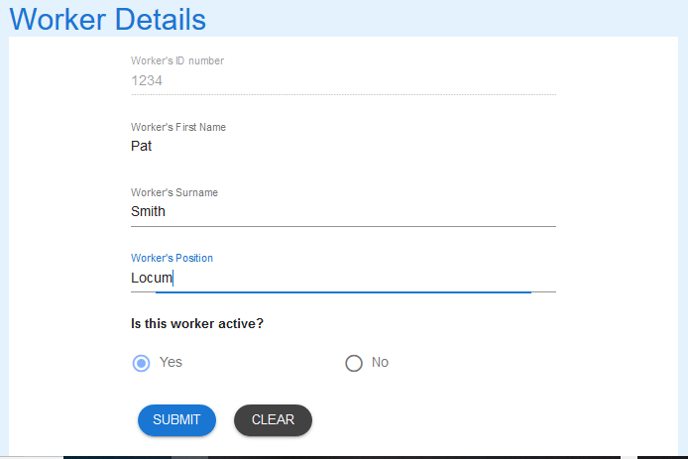

1. Select SUBMIT to update the record.



1. A successful update will receive the following message.



## Field Information

### Worker’s ID Number

1. This ID number cannot be amended once it has been entered.
2. If is incorrect, the worker will need to be made inactive and re-entered using the **“Manage Workers”** user guide.

### Is this Worker Active?

1. If the worker is no longer working for the organisation, change this field to “No”.
   1. Workers that are not active will not appear in the list of workers in the Log Error Form.
2. If an inactive worker recommences employment with the organisation, change this field to “Yes”
   1. Active workers will appear in the list of workers in the Log Error Form.

RETURN TO CONTENTS PAGE

# Metabase - Introduction

## Scope and Purpose

The purpose of this user guide is to provide instructions on how to use the reporting feature - Metabase.

* This feature is only available to a user with administrator rights.

## Process Overview

The administrator will need to log into PET using their valid username and password (see 5.1).

* The Welcome Page will be presented on successful login.
* The administrator will need to select Reporting via the menu bar button Reports or the Reporting button on the menu page.

# Metabase - Procedures

Metabase is an open source business intelligence tool. It lets you ask questions about your data and displays answers in formats that make sense, whether that’s a bar graph or a detailed table.

Your questions can be saved for later, making it easy to come back to them, or you can group questions into great looking dashboards. Metabase also makes it easy to share questions and dashboards with the rest of your team. This user guide is based on the user guide provided by the Metabase website:

<https://www.metabase.com/docs/v0.18.1/users-guide/start.html>

To access Metabase, you will need to access PET through an administrator login.

## Metabase – Processing Steps

Metabase has been provided as a reporting tool for PET. Data lists as well as graphics are available for the user. These reports can be download and shared with others.

### Navigate to Metabase

1. From the Welcome Page, there are two ways to navigate to “Metabase”:
   1. Select the “Reporting” from the list



* 1. From the Menu Bar, hover your mouse over “Reports…” and select “Reporting”



1. The Metabase login page will appear.

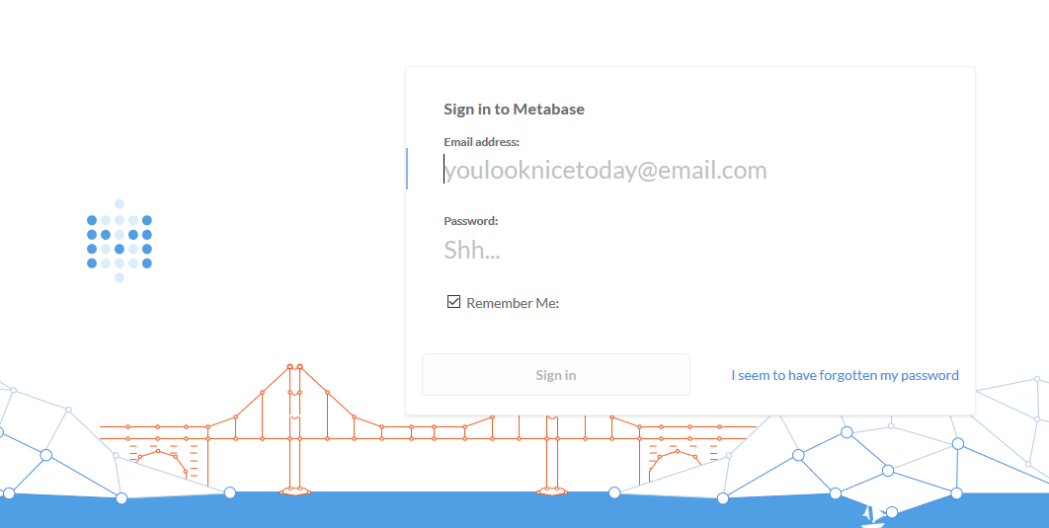

### Login to Metabase

1. Enter the login and password to access Metabase.

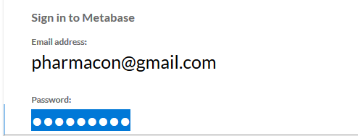

1. Select the enter and you will be taken to the welcome page.

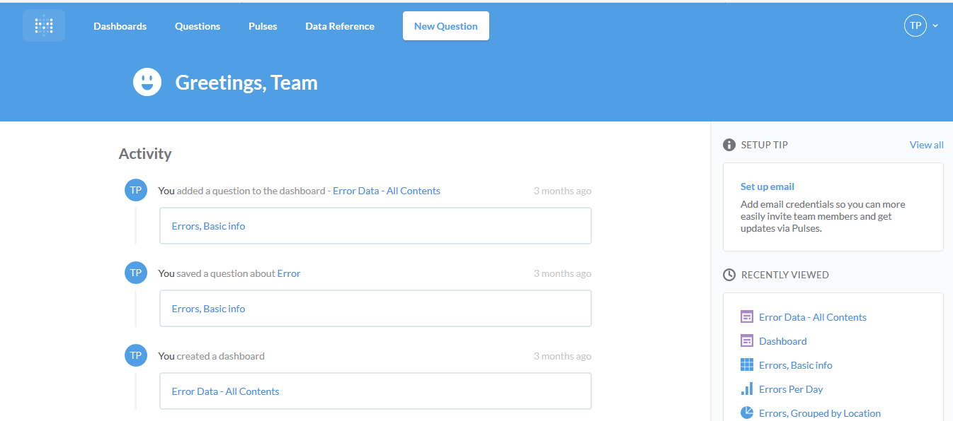

1. A direct selection of a previously saved activity can be made from the list on this page.
2. To see the dashboard, select “Dashboards” from the menu bar.



1. Saved dashboards will appear.

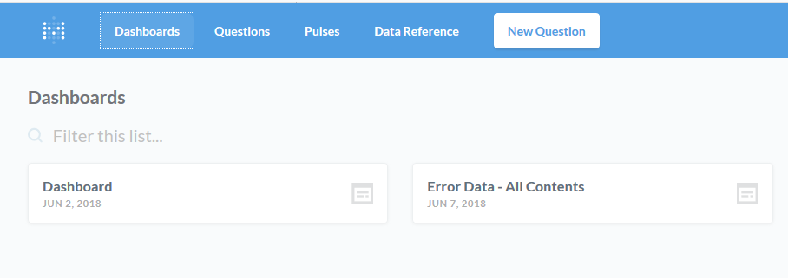

1. Selecting a dashboard will show the results of the query/queries.

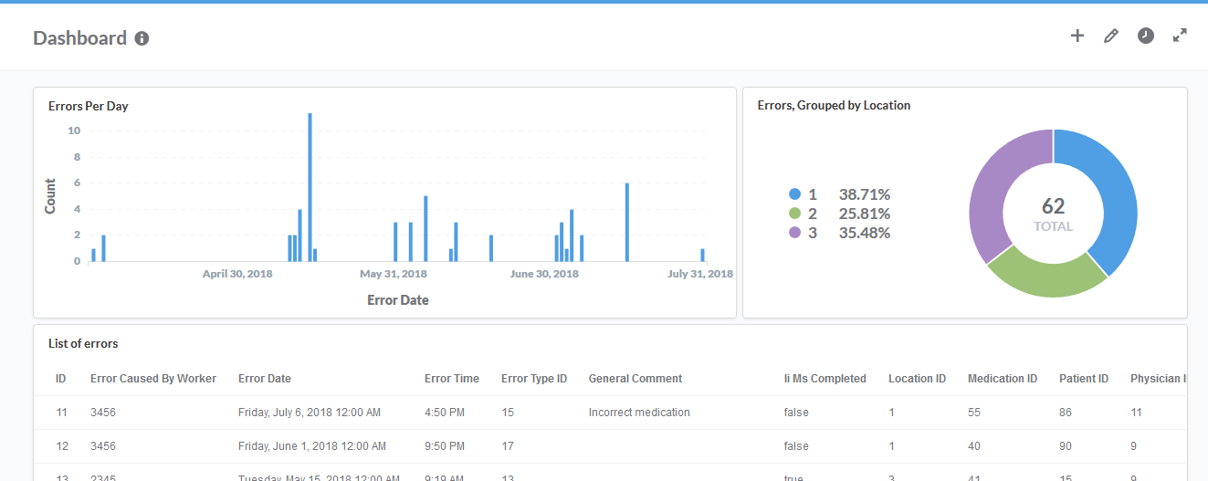

1. Selecting Questions from the menu bar will show the details of the saved questions previously asked of the database.

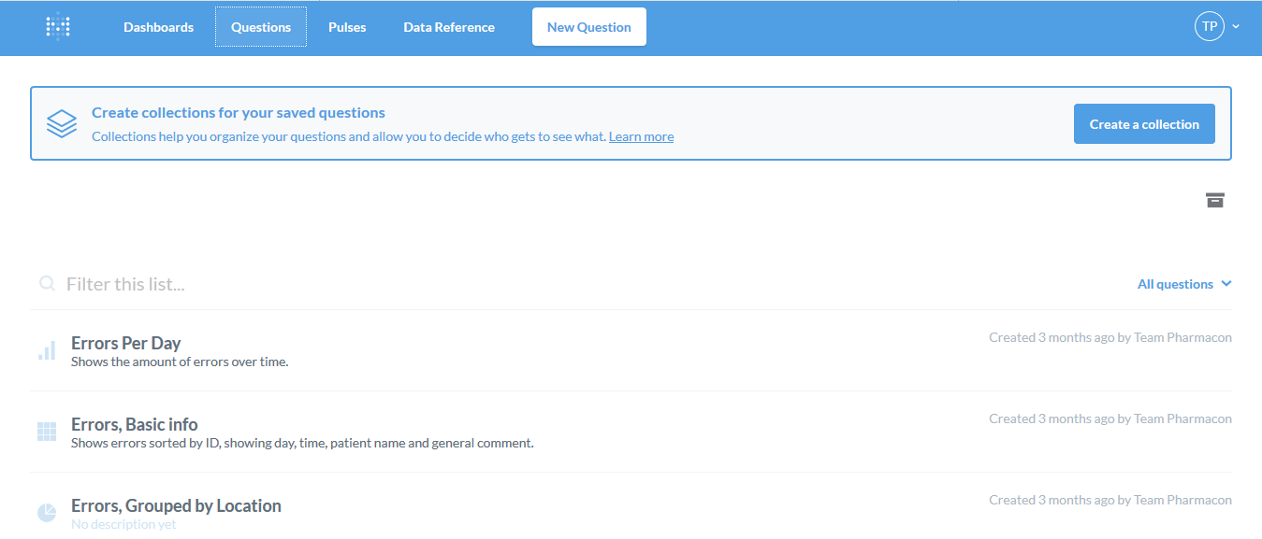

### Metabase URL Links

1. Metabase provides a user guide for the various functions available.



1. URL links to these various functions are listed below  
   <https://www.metabase.com/docs/v0.18.1/users-guide/01-what-is-metabase.html>

<https://www.metabase.com/docs/v0.18.1/users-guide/02-database-basics.html>

<https://www.metabase.com/docs/v0.18.1/users-guide/03-asking-questions.html>

<https://www.metabase.com/docs/v0.18.1/users-guide/04-visualizing-results.html>

<https://www.metabase.com/docs/v0.18.1/users-guide/05-sharing-answers.html>

<https://www.metabase.com/docs/v0.18.1/users-guide/06-dashboards.html>

<https://www.metabase.com/docs/v0.18.1/users-guide/07-dashboard-filters.html>

<https://www.metabase.com/docs/v0.18.1/users-guide/08-multi-series-charting.html>

<https://www.metabase.com/docs/v0.18.1/users-guide/09-pulses.html>

<https://www.metabase.com/docs/v0.18.1/users-guide/10-metabot.html>

<https://www.metabase.com/docs/v0.18.1/users-guide/11-data-model-reference.html>

*RETURN TO CONTENTS PAGE*

If you encounter issues not addressed by this user guide, please contact your account manager for additional support.